Multi-disciplinary and Multi-objective Optimization Considering Aircraft Program Cost and Airline Network

José Alexandre T. G. Fregnani[1] Bento Silva de Mattos[2] and José Antonio Hernandes[3]

Technological Institute of Aeronautics (ITA)

12228-900 São José dos Campos, São Paulo, Brazil

The determination of optimal aerial networks and their flight frequencies is crucial for the strategic planning of airlines, for aircraft and crew rostering, their survival in a competitive environment, and for establishing new profitable routes. Optimum airplane types for networks are also crucial to improve revenue and to reduce operating costs. Besides airlines, airframe manufacturers need identify airplane configurations that better suit airline operations and establish list prices for their products as well as how much the development and market of such configurations will cost. To address these issues, the present study describes and applies a methodology to determine the optimal aerial transport network simultaneously with the identification of the optimum fleet for that network, namely, an integrated design. In the optimization simulations carried out in the present work, airline fleets are composed of three types of airliners, selected according to their passenger capacity. Airplanes are designed with high-fidelity methods, realistic performance calculations and must obey a set of requirements, including some related to certification according to FAR 25 rules. Optimization for a Brazilian network considering 21 cities was carried out with the maximization of the network daily profit and the minimization of the fleet acquisition cost. A comprehensive airplane manufacturer program cost estimation model was implemented, enabling the calculation of net present value of the program and financial parameters.

|  |  |  |  |
| --- | --- | --- | --- |
| Nomenclature |  |  | |
| |  |  |  | | --- | --- | --- | | *ADj* | = | Arrival delay at airport j [min] | | *B* | = | City pair combined buying power index | | *Bi* | = | Buying power index related to the city of the *i-th* airport | | *BPR* | = | Engine by-pass ratio | | *b* | = | Passenger capacity | | *bk* | = | Passenger capacity of *k-th* aircraft | | *CARGO* | = | Total cargo loaded onboard [kg] | | *C* | = | City pair airport catchment area product | | *Ci* | = | City pair airport catchment related to the *i-th* airport [km2] | | *CD* | = | Drag coefficient | | *c*k | = | Average direct operational cost [$/nm] of *k-th* aircraft at design range | | *Cflt* | = | Flight component of direct operational cost (crew, oil, fuel and insurance) [US$/nm] | | *Cmaint* | = | Maintenance (labor and material) component of the direct operational cost [US$] | | *Cdepr* | = | Depreciation (airframe, engines and avionics) component of the direct operational cost [US$] | | *Cfee* | = | Fees (Navigation, Airport and Register) component of the direct operational cost [US$] | | *Cfin* | = | Financial (airframe and engine leasing) component of the direct operational cost [US$] | | *CL* | = | Lift coefficient | | *CLmax* | = | Maximum lift coefficient at undeflected flap/gear up airplane configuration | | *De* | = | Engine fan diameter [m] | | *DDi* | = | Departure delay at *i-th* airport [min] | | *dij* | = | Distance from *i-th* to *j-th* airport [nm] | | *DOC* | = | Direct operational cost [US$/nm] | | *DOCijk* | = | Direct operational cost from *i-th* to *j-th* airport [US$/nm] | | *DU* | = | Average daily aircraft utilization [h] | | *eTIT* | = | Engine turbine inlet temperature [K] | | *fij* | = | Daily demand from airport *i-th* to *j-th* airport | | *FF* | = | Engines fuel flow [kg/s] | | *FOB* | = | Total fuel on board [kg] | | *FPR* | = | Engine fan pressure ratio | | *g* | = | Gravity acceleration [m/s2] | | *G* | = | Combined city pair Gross Domestic Product | | *GDPi* | = | Gross Domestic Product related to the city of the *i-th* airport [US$] | | *Hmaxbuffet* | = | Maximum pressure altitude limited by buffet margin [ft] | | *Hp* | = | Pressure altitude [ft] | | *ID* | = | Average inflight delay cost [US$/min] | | *k1* | = | Total operational costs to direct operational costs ratio | | *k2* | = | Total revenue to ticket revenue ratio | | *LATi* | = | Latitude of the origin airport [o] | | *LAtj* | = | Latitude of the destination airport [o] | | *LFref* | = | Reference Load Factor | | *LONi* | = | Longitude of the origin airport [o] | | *LONj* | = | Longitude of the destination airport[o] | | *M* | = | Number of Mach | | *MAXFUEL* | = | Maximum fuel capacity [kg] | | *MILP* | = | Mixed Integer Linear Programming | | *MLW* | = | Maximum landing weight [kg] | | *MMO* | = | Maximum Operating Mach Number | | *MTOW* | = | Maximum takeoff weight [kg] | | *MZFW* | = | Maximum zero fuel weight [kg] | | *Nacftk* | = | Total number of *k-th* aircraft | | *NAND* | = | Nested analysis design | | *NDOC* | = | Total air transport network’s direct operational cost [US$/ nm] | | *NP* | = | Total network profit [US$/(passenger.nm)] | | *OEW* | = | Operational Empty Weight [kg] | | *OPR* | = | Engine overall pressure ratio | | *p* | = | Average ticket price [US$] | | *P* | = | City pair population product | | *Pi* | = | City pair population related to the city of the *i-th* airport | | *PAX* | = | Passenger or Passengers | | *PAXWT* | = | Total passenger’s weight including baggage [kg] | | *PAYLOAD* | = | Total payload carried by the aircraft [kg] | | *SAND* | = | Simultaneous analysis and design | | *Tnet* | = | Net engine thrust [N] | | *Tij* | = | Trip time spent between *i-th* and *j-th* airports [min] | | *TBij* | = | Block time spent between *i-th* and *j-th* airports [min] | | *TIT* | = | Average taxi in time [min] | | *TOT* | = | Average taxi out time [min] | | *TAT* | = | Average turnaround time [min] | | *TOF* | = | Takeoff fuel (fuel on board at beginning of takeoff run) [kg] | | *TOW* | = | Takeoff weight [kg] | | *V* | = | True airspeed [m/s] | | *W* | = | Airplane weight [kg] | | *Wf* | = | Total fuel burned from origin to destination airport [kg] | | *Wfapp* | = | Total fuel burned on approach phase [kg] | | *Wfalternate* | = | Total fuel burned from destination to alternate airport [kg] | | *Wfcontingency* | = | Contingency fuel [kg] | | *Wfholding* | = | Fuel for the holding flight phase [kg] | | *Wftaxi* | = | Taxi fuel [kg] | | *Xiltj* | = | Fraction of the passenger’s demand flow *fij* from origin *i* to destination *j* | | *Yijk* | = | Number of type-*k* airplane linking *i-th* to *j-th* city (route frequency) |  Subscripts  |  |  |  | | --- | --- | --- | | *β* | = | Temperature/altitude drop ratio at troposphere [-0.00 1982 oC/ft] | | *δmax* | = | Atmospheric pressure ratio (actual static pressure / standard sea level pressure) at maximum altitude | | *γ* | = | Flight path angle [rad] | | *∆ISA* | = | Temperature deviation from standard temperature [oC] | |  | = | Acceleration factor function | | ∞ | = | Freestream properties | | |  |  |

# Introduction

The need for reduction of operational cost is widely agreed by the commercial air transportation industry. Indeed, the segment is characterized by low operational margins. As per recent studies [1], since the 80´s the average world airlines profit margin has demonstrated a narrow variation, from -4% to 3%. Optimization methods have been widely applied to reduce operational costs, such as fuel-efficient flight paths, optimum slot allocation and turnaround time reduction [2] [3] [4] [5]. They are applied in the airline´s operational planning process, which is divided into three major blocks, as shown in **Fig. 1**.

**Block 3**

Crew Assignment

* Rostering/Pairing

**Block 2**

Fleet Assignment

* Tail Assignment

**Block 1**

Schedule Generation

* Route allocation
* Flight Frequencies

**Fig. 1** **Typical operational planning process of airlines**.

The interdependence of these blocksis worth mentioning, where costs and revenues are forwarded to each next step in the airline planning cycle [6] [7]. Because of this, sometimes optimization models are set up to solve the entire cycle problem at once, where the minimization of costs or maximization of revenues are set as objective functions in a multiobjective optimization problem [3]. However, this approach very large-scale problems may arise, with the involvement non-linear programming algorithms [8] and therefore significant computational power may be required for the complete solution. The most common solution adopted is the optimization of each block separately [2] [3] [4] [5].

It is worth mentioning that the selection of the aircraft fleet types suited to the network is indeed performed prior to the optimization of Block 1, which is a significant factor that influences the flight frequencies. The determination of the optimal flight network and associated frequencies is a key step for airlines to elaborate their strategic planning, from market determination to aircraft and crew rostering. An optimal solution for this block facilitates the solution for the others. Furthermore, if the optimum aircraft types are associated with the assigned network, revenue and/or minimum operational costs can be even further improved. In other words, the network optimization is normally carried out separately from the aircraft optimization in the airline planning process.

At this point, some aspects related to the conceptual design of commercial transport airplanes deserve to be mentioned. This process is generally carried out by aircraft manufacturers through optimization of the averaged direct operational cost within a given set of ranges. Most of the tools used at this phase are simplistic, modeling aeronautical disciplines with lower fidelity than on the design phase. Thus, the aircraft configuration and flight performance models are usually refrained from the details of final product in this approach. In addition, the suitability of the product into a realistic airline network are not usually considered. In fact, aircraft manufacturers perform aircraft design optimizations focused mostly on subsystems requirements, usually ignoring the high degree of dependency that exists between airplane (of family of airplanes) and network, resulting in a suboptimum solution for airlines. Therefore, there is a need for an integrated process at once, where both aircraft (or family of aircrafts) and aerial networks are optimized simultaneously [9].

1. **Literature Review**

The Airline Deregulation Act, enacted in late 1978 by the North American government, presented a set of economic and operational measures tailored to lower the level of control on airfares, routes and stimulate the entry of new airlines into the aviation market. Consequently, the power of civil aviation regulators over fares was eliminated, establishing market forces for the first time in the history of airline industry. Ever since, this model has been quickly replicated in other countries as a form to support the growing passenger demands worldwide.

Due to fierce competition between airlines, Hub-and-Spoke networks have evolved as the minimum cost configuration for Legacy Airlines while fully connected networks have become the emerging solution for the Low-cost Carriers in their competition for growing markets. Since then, boosted by these industry trends, various research initiatives were conducted on network optimization techniques with the objective to maximize profit for airlines.

Ahuja, Ravindra, Magnanti, Thomas, Orlin, James, and Reddy [10] performed a detailed study about applications for network optimization problems in several fields of operational research, including the ones related to transportation. His study addressed cost minimization using linear programming models. Campbell [11] performed another study presenting an integer programming formulation for four types of hub-allocation problems, featuring discrete hub centers and models. Aykin [12] studied hub location and routing, proposing an interactive method to solve both problems separately.

Jaillet, Patrick, Song, Gao, Yu, and Gang [13] introduced an innovative flow-based linear model for designing networks presenting minimum cost and their associated frequencies, considering local demands. The proposed model can predict the occurrence of hubs if they reveal to be cost effective. A detailed study regarding network types and schedules was performed by Lederer and Nambimadom [14], where analytic expressions for passengers and airline costs were derived for several network types. Parametric studies were conducted to evaluate the effect of distances, demands and frequencies on profit with the aim of profit optimization. [12].

Evans, Schafer, and Dray [15] proposed a model for network optimization considering flight scheduling and constraints on airport capacity. Complementing these studies, Bing [16] developed metrics to evaluate efficiency of the transport networks featuring any kind of topology. More recently, Caetano and Gualda [6] have proposed a solution for jointly route assignment and fleet scheduling using a simplified linear program model. In another study [7], both authors described the so-called transport momentum methodology as a proxy for operational costs that are tailored for solving fleet assignment problems encompassing scheduling.

Passenger demand is an important input to be considered in the network optimization process. Gravitational models became popular to determine passenger demand in air transportation mainly because of their simplicity and forecast capacity using historical econometric variables related to the cities involved and time-geometric parameters. In this kind of model, a simple multivariable log-linear regression is enough to determine the associated coefficients with relatively good accuracy. Grosche et. all [17], for example, propose a complete model considering population, catchment area, buying power index, gross domestic income, time to travel and distance between city pairs, using data from 28 European airports for calibration. Doganis [1] proposes a different approach, estimating the passenger demand of airports considering airfares, frequency and scheduled traffic. Wojan [18] determines the characteristics of the optimum airline networks using gravity models. In his work the demand and cost conditions of an airline have been identified as one of the main determinants of network topology.

Few studies integrate aircraft design characteristics and performance to realistic mission analysis for each city pair considered. The research on integration of entire airline networks with aircraft design variables started to be developed in the last ten years and has only been possible with the increase of computational power and development of robust optimization solvers which are capable of handling multivariable, multi-objective functions and are submitted to non-linear constraints. Recent studies show that the direct coupling of aircraft design and airline fleet-route allocation frequently use mixed-integer, nonlinear programming (MINLP) formulation, a suitable solution via a decomposition approach [19] [20]. It is worth to mention that most of the researches are until now directed to the identification of aircraft characteristics that reduce direct operational costs.

Taylor and de Weck [21] presented an article of the benefits of optimizing an integrated air transportation network and vehicle design, concurrently defined. Their case study focuses on the design of an air transportation network for overnight package delivery on two turn-around hub configurations connecting seven U.S. cities. By concurrently optimizing both the vehicle with the Breguet Range equation and network for a selected few cities with fixed demand, it was possible to obtain a minimum of a ten percent improvement in operational costs over the one obtained by optimizing the network design using a set of pre-defined aircraft. This was accomplished by embedding a linear programming solver in the perturbation step of simulated annealing to solve the substantial number of linear constraints imposed by the capacity and demand requirements of the network.

Bower and Kroo [22] presented a methodology for aircraft design considering demands of a given aerial network. In their design approach, the objectives are the minimization of direct operating costs and airplane emissions (CO2 and NOX). For this purpose, a hierarchical decomposition was used with discipline-specific optimization algorithms using simplistic models. A modified version of the NSGA-II multi-objective genetic algorithm is implemented in the system level aircraft design subspaces. The IBM ILOG CPLEX Optimization Studio is also employed to solve fleet assignment subspace problems. Results were presented for a test problem that involves designing a single aisle commercial aircraft for a route network consisting of four cities and eight route segments, using eighteen design variables. Davendralingam and Crossley [23] proposed a unifying conceptual framework on concurrently design aircraft and the operational network by incorporating established passenger demand models. A conceptual scenario involving six airports is formulated and solved to exhibit the methodology employed and showing reflexivity of demand. In subsequent studies [24] [25] the authors investigate the impact that aircraft design choices have on target market capture decisions, which impacts on demand itineraries and business risks. Finally, Siqueira et.al [26] proposed an MDO framework to select the optimum conceptual aircraft design for an existing scheduled airline network. Moreover, Versiani, Paglione, and Mattos [27] developed a framework to optimize families of aircraft for a given mission using genetic algorithms.

Hwang and Martins [28] propose a concurrent optimization encompassing aircraft design, mission profiles, and the allocation of aircraft to routes in an airline network. To enable this, a gradient-based optimization approach was adopted with a parallel computational framework, which boost the computation of derivatives in the multidisciplinary analysis. A surrogate model for the CFD analysis is retrained in each optimization iteration given the new set of shape design variables. Their optimization problem contains over 6,000 design variables and 23,000 constraints, and it is solved in approximately 10 hours on a machine with 128 processors. The optimization revealed a 27% increase in airline profit when comparing the allocation-mission-design optimization to allocation only optimization. Considering the aircraft design side, MDO may vary at single level and multilevel optimization. In single level approach, both disciplinary and system design variables are determined by the system optimizer, while in the second one system and design variables have their own optimizers. In addition, simultaneous analysis and design (SAND) or nested analysis design (NAND) may be chosen, per the size and complexity of the problem. In SAND both disciplinary design and state variables are determined by the optimizer, while in NAND only disciplinary design variables are determined [29]. On aircraft design problems, the involving network is likely to be adopted the multilevel optimization and NAND approaches. Many forms of approximation methods were developed to model disciplines to enhance the speed of the optimization when heavy computations are required. Recently surrogate models (such as Kriging interpolation and artificial neural networks), have been providing satisfactory results replacing heavy aerodynamic and structural modeling [30]. The mission investigation integrated to aircraft design was proposed by the first time by Isikveren [31], where the optimized range and fuel consumption are calculated via semi-empirical formulae using aircraft design variables. Cavalcanti, Mattos, and Paglione [32] and Cabral, Paglione, and Mattos [33] proposed a multi-objective optimization of wing planform carried out by the minimization of the block time and block fuel for a given mission. Henderson developed an environmental design framework to design and optimize aircraft for speciﬁc environmental metrics [34]. Since then MDO is proposed to be used to optimize aircraft by simultaneously considering airframe, engine and mission design. However, the research on integration of detailed airplanes with a network turned into considerable development in the last ten years only. This was made possible thanks to the increase of computational power and development of robust optimization solvers, capable to handle multivariable, multi-objective functions and submitted to non-linear constraints. Finally, Cabral, Paglione, and Mattos. [33] presented a computational tool for the conceptual design of families of aircraft for a given mission using the MDO framework. Twenty design variables were employed and four disciplines, using Class-I modeling. Expanding this methodology Siqueira. Mattos, and Loureiro [35] developed a methodology for aircraft optimal conceptual design employing advanced turbofan engine and airplane models. Wing and engine position in the configuration, number of engines, tail configuration, wing and horizontal tail geometries are adopted as design variables.

1. **Objective and scope**

The optimization framework of the present work proposes the determination of the optimal aerial transport network simultaneously with the optimum fleet for this network. The fleet can be composed of an arbitrary number of airplane types or versions and here three seat capacities were considered. Basically, airplanes were selected for an optimization task according to passenger capacity: 44 to 69 for the first model; 70-99 for the second; and 100-156 for the third.

The major contributions of this research may be summarized as follows:

1. Aircraft design is integrated into any airline network to be optimized, considering a realistic operational profile, airport runways and passenger demand.
2. A database of airplanes with the most distinguished characteristics is employed in the process. Optimal fleet is then determined from the combination of airplanes which compose this database. This ensures faster convergence of the optimization process. Airplanes resulting from the optimization process can be further improved in an off-design process and their impact on the network can be easily analyzed.
3. Many design parameters are used to represent the airplane in finest detail with accurate aerodynamic, stability and control, and performance calculations, necessary for realistic mission analysis.
4. Aircraft are generated according to the following design features:
   1. Adherence to FAR 25 requirements: climb rate at 2nd segment, missed approach, takeoff field length, landing field length, climb rate at service ceiling, cruise speed, and adequate fuel storage.
   2. Calculation of noise signatures at ICAO certification points: sideline, approach, and takeoff [9].
   3. Innovative method for turbofan engine weight: coupling with engine deck program guarantees accurate weight calculation.
   4. Engine emissions are calculated for any airplane and can be considered in the optimization process if required.
   5. Realistic landing gear sizing and integration into the configuration avoiding flaps being affected by wake generated by wheels and hit by engine hot exhaust gases.
   6. Proper sizing of wheel tires selected from tables containing internal pressure, loads, speed and other parameters. Main landing gear trunnion is positioned between the rear and auxiliary spars of the inner wing.
   7. Ditching requirements are considered for fuselage cross-section sizing.
   8. Engines of underwing configurations are positioned in such way to avoid uncontained fan debris to hit fuel tanks.
   9. An Artificial Neural Network (ANN) system is employed to calculate the aerodynamic characteristics of the airplane configurations, based on full potential formulation with viscous correction [36]. The use of the ANN enabled a high degree of accuracy and fidelity for the aerodynamics of the present work, allowing performance calculations in a level never achieved in conceptual design before.
5. Realistic airline mission performance calculation, which also considers true airline operations parameters, was employed.
6. Optimal airplane fleets are obtained considering maximization of network profit and manufacturer´s aircraft list price. The latter is obtained with module that calculates the Net Present Value (NPV) of an aircraft program, thus considering the airplane manufacturer side in the computations.
7. City pair demands are calculated via gravitational model.
8. The determination of the optimum network considers a two-stop route model and three airplane types composing the airline fleet. This is solved in a MILP sub-procedure for obtaining the network with maximum profit.
9. A test case considering the 21 major Brazilian airports was run and optimum networks that were obtained from the computations are analyzed and discussed.

# Methodology

1. **General description and structure**

The structure of the MDO framework is shown in **Fig.2**. There, as exemplification, the optimal aircraft fleets, are composed of three aircraft types. Objectives are the maximization of network profit (NP), satisfying given city-pair passenger demands, and the minimization of fleet acquisition list price. MATLAB® is employed as integrating platform.

The airplane databases were built according to three ranges of passenger capacity. The first one considers airplanes with capacity ranging from 44 to 69 seats and is comprised of 13 individuals; the database No. 2 hosts 12 airplanes transporting between 70 and 99 passengers; finally, the third database has 17 types of airplanes featuring between 100 and 156 seats. Thus, there are 2,652 potential combinations to be explored in the design space.

A routine retrieves all the necessary data related to the three selected airplanes such as engine parameters, weights, fuel capacity, noise signature, passenger accommodation, fuselage dimensions, range, and others. The Mission performance module calculates the fuel burn, trip time, and direct operating cost for a mission between the departure and destination airports. In addition, it also provides takeoff weight and ambient conditions. This module calls the aerodynamic and propulsion module routines to determine the necessary fuel flow and drag for the trajectory calculations. Before running the network optimizer module, this module calculates the DOC for each aircraft to the related range. This module is also used by the network analysis module to determine the fuel burn, travel time and DOC of each sector of the optimized network.

The network optimizer module embodies a Mixed Integer Linear Programming problem. MILP problemsare generally solved using a linear-programming based branch-and-bound algorithm [37] [38]. Typically, LP-based branch-and-bound procedure begins with the original Mixed Integer Programming (MIP). Not knowing how to solve this problem directly, all the integrality restrictions are removed. The resulting Linear Programming (LP) is called the linear-programming relaxation of the original MIP. It is then possible to solve this LP. It is a matter of chance if the result happens to satisfy all the integrality restrictions, even though these were not explicitly imposed. This solution is an optimal solution of the original MIP, and the search for optimal solution is over. If not, as usually is the case, the normal procedure then is to pick some variable that is restricted to be integer, but whose value in the LP relaxation is fractional. To get an upper bound on the objective function, the branch-and-bound procedure must find feasible points. A solution to an LP relaxation during branch-and-bound can be integer feasible, which can provide an improved upper bound to the original MILP. Certain techniques find feasible points faster before or during branch-and-bound. Most MILP algorithms, including the one used here, use these techniques at the root node and during some branch-and-bound iterations. These techniques are heuristic [37], meaning they are algorithms that can both succeed and fail.

The optimum networks for a set of three airplane types are determined simultaneously based on airport and econometric information, retrieved from a database, aircraft maximum passenger capacity, aircraft design range and associated DOC. This is an optimization task within another larger one (**Fig. 2**).

**Fig. 2 Airplane/Network integrated design optimization framework.**

In the Network analysis module, fuel burn, trip time, and DOC for all sectors are calculated and compiled to calculate the total network profit and Manufacturer´s Cashflow Net Present Value, the latter delivering as by-product the list price of all airplanes from the database. The fleet Optimizer module generates the design variables, the set {Airp 1, Airp 2, Airp 3}. These are indeed integer variables directly linked to database indexes of the airplanes. After this, all data related to the airplanes are passed to the performance module. Network profit and the fleet acquisition price are processed in this module.

The Multi-objective MOGA-II algorithm [39] was employed in the computations carried out here. It is robust and can handle global minima or maxima inside a complex design space built with many variables. This first-generation evolutionary algorithm is designed to use inherent genetic operators (crossover, mutation and selection) combined with parenting elitism, which means that it always favors individuals with better fitness values than its parents. The algorithm was set up to run 20 generations, with 50% probability of crossover, 5% probability of selection and 1% probability of mutation. The uniform Latin hypercube sample algorithm [40] is used to generate the starting points for the GA optimization. In the present study, the generations were comprised of 20 individuals.

Design ranges for the airplanes of the three databases are defined at the point of typical single-class passenger capacity considering takeoff with MTOW. Each aircraft in the databases is represented by 61 parameters, which are associated to airframe, performance, propulsion and aircraft systems. Some constraints and certification requirements are shown from **Tables I** to **II**, some of themcontaining detailed information about design constraints and parameters. Some design characteristics are described below:

1. Stall shall start at a wing inward station from a prescribed distance from ailerons.
2. Satisfy required climb rate at 2nd segment of climb and at initial cruise altitude.
3. Fuselage sized properly to comply with ditching requirements.
4. Fuel for a mission with typical payload shall be stored in the available space in wing and fuselage.
5. Engine core exhaust shall not hit the flaps and clearance to ground must be obeyed.
6. Engine fan debris resulting from a catastrophic failure shall not hit wing fuel tanks.
7. FAR 25.121 balked landing and FAR 25.119 landing climb requirement must be fulfilled.
8. Landing field length and Takeoff balanced field length lower than a prescribed value.
9. Enough thrust to cruise at MMO at service ceiling in desired cruise segment.
10. Horizontal and vertical tails are sized to fulfill criteria of controllability and static stability.
11. Landing gear is designed to withstand static and dynamic loads, consider key speeds, and to obey geometric constraints. Guideline for nose landing gear tire sizing is minimum possible size, and that for the main landing gear tires is minimum weight.

**Table I Airframe and performance parameters**

|  |  |
| --- | --- |
| Parameter | Characteristic/Value |
| **Passenger cabin external width** | Calculated to fulfill clearances, ditching, container type, and other cabin parameters or requirements |
| **Passenger cabin external height** | Calculated to fulfill clearances, ditching, container type, and other cabin parameters or requirements |
| **Fuselage length** | Based on seat arrangement, emergency exits, galley and toilet areas |
| **Tailcone** | Adjusted to host tailplanes, engine (if placed there) and some aircraft systems like the APU |
| **Airplane PAX capacity at 32-in pitch, single class** | From 44 to 156 |
| **Number of aisles** | 1 |
| **Seating abreast** | 4 - 6 |
| **Cabin crew** | 1 + 1 for every 50 PAX |
| **Cabin aisle width [m]** | 0.50 m (It may suffer changes according to adjustments to comply with ditching requirements) |
| **Cabin height [m]** | 2.00 m |
| **Seat width [m]** | 0.46 m |
| **Container type** | None or LD-45W |
| **HT configuration** | Conventional or “T” tail |
| Wing reference area [m2] | 48 🡺 124 |
| Wing aspect ratio | 7.5 🡺 9.2 |
| Wing taper ratio | 0.25 🡺 0.43 |
| Wing sweepback angle at quarter chord | 20o 🡺 28o |
| Flap deflection @ takeoff | 35o |
| Flap deflection @ landing | 45o |
| Slat | Can optionally be incorporated into the configuration with weight penalty and improved *CLmax* |
| Location of break station (fraction of semispan) | 0.31 🡺 0.34 |
| Incidence angle at wing root [deg] | 2 🡺3o |
| Incidence angle at break station [deg] | 0🡺 0.5o |
| Incidence angle at wingtip [deg] | -1 🡺 -5o |
| Airfoils | A set of available airfoils were assigned to compose the wings |
| Winglet | Can be considered or not into the configuration |
| Service ceiling | 37,000 - 41,000 ft |
| Range with typical PAX payload (MTOW, sea level, ISA) | 1,290 - 2,400 nm |

**Table II Powerplant Parameters**

|  |  |
| --- | --- |
| Parameters | Min - Max |
| **De [m]** | 1.14 - 1.52 |
| **BPR** | 3.04 - 6.20 |
| **FPR** | 1.32 - 1.85 |
| **OPR** | 21.00 - 30.00 |
| **eTIT [K]** | 1320 - 1420 |
| **Number of engines** | 2 |
| **Engine location** | Underwing configuration or at rear fuselage |

The aircraft database is generated through random variation of most parameters within a specific interval, as listed in the tables. It is noticeable that some of them are kept fixed to simplify the calculations in some modules. Some parameters of tail surfaces are kept fixed in this study with the objective to simplify the tail sizing computations.

For the airplane design, Maximum Takeoff Weight, Maximum Landing Weight and Operational Empty Weight of each aircraft are calculated through an iterative process which is illustrated in **Fig. 3**. In this calculation weight of engine nacelles, fuselage, empennage, airplane systems, landing gear are calculated separately using empirical formulae [41] [42]. The wing weight is calculated by sizing the wingbox to withstand aerodynamic loads calculated with a full potential code in some few maneuvers in the flight envelope [43]; the secondary wing structure is estimated by empirical methods. All these weights are considered for the determination of the Operational Empty Weight. With the weight of each component, it is also possible to obtain the center of gravity (CG) of the aircraft and its variation with fuel consumption and different payloads. MTOW and MLW are then estimated interactively using the mission analysis module and the calculated OEW the given design range [9].

**Fig. 3** **Flowchart of airplane calculation including key mass figures.**

1. **Network Optimizer**

Provided the airplane triplet {Airp 1, Airp 2, Airp 3} is known, the optimum network, including the necessary frequencies, is solved in a secondary optimization process using a mixed linear programming algorithm. The aircraft allocation (tail assignment and schedule for each frequency) is not considered in the present framework and will be considered in future work. The airline networks are optimized considering operations within a certain geographical area with a certain market share. For this, it is necessary that passenger demand among airports, average ticket price, aircraft fleet capacity, range, and operational costs be known. Then, an optimized network can be drawn up considering the profit maximization. In this context, the profit is maximum if all potential of passenger demand is fulfilled for each city pair, allocating the necessary frequencies for each aircraft type. Also, it is assumed that the airline allows passengers to buy tickets for maximum two stops between origin and destination, meaning that three types of services are possible: non-stop flights, one-stop connecting flight, and two-stop connecting flights. In fact, this is a common policy practiced by the Brazilian domestic airlines nowadays.

The optimization algorithm in this module is derived from the Linear Programming Model (LPM) elaborated by Jaillet and Yu [13] for generic network determination considering passengers fractional flow. A MATLAB® code was developed to set up and solve this problem using the LPM solver available for this application. The mathematical formulation of the problem is presented in the next paragraphs.

Let be the fraction of the passenger’s demand flow from origin *i* to destination *j*, served by a two-stop connecting flight through cities *l* and *t*, the number of aircraft type used in the route from city *i* to *j*, p the average fare per passenger ($),the average operational cost ($/nm) at design range , *bk* the passenger capacity of aircraft *k*, the reference load factor *LFref* and *dij*the distance between origin and destination airports. The following integer linear programming model is proposed:

|  |  |
| --- | --- |
|  | (1) |

subject to:

|  |  |
| --- | --- |
|  | (2) |
|  |
| , for all *i≠j* | (3) |

where , are positive and integer positive for all *i≠j*

The average operational costs (*Ck*) for each aircraft fleet, necessary for the optimization, correspond to the Direct Operational Costs related to the design range mission. The objective function (1) is set to maximize the network profit, based on the difference between the average fare (*p*) and the average cost per passenger. Constraint (2) states that the fractional flow on route *ij* cannot exceed the total capacity of the aircraft assigned, while constraint (3) ensures that the passenger flow from a direct flight from *i* to *j* is non-negative.

It is assumed that 50% of all passenger demand from *i* to *j* are derived from direct flights ), 30% distributed equally among all one-stop flights and 20% distributed equally among two-stop flights . Passengers potential demand between origin and destination (*fij*) is determined via gravitational model, based on city pair distance and econometric parameters. Let *P* be the city pair population product (*P=Pi.Pj*), C the city pair airport catchment area product (), B the city pair combined Buying Power Index (), *G* the city pair GDP product (*G=GDPi..GDPj*) and *dij* the reference distance of the city pair. The following passenger demand model is proposed as follows:

(4)

In **Equation 4**, the exponents *K0*, *K1*, *K2, K3, K4* and *K5* are calibration constants, determined by log-linear regression [18]. They may be easily calculated using the public econometric data available (*Pi, Ci, Bi* and *GDPi* often published by economic agencies).

1. **Mission performance**

Performance calculation is an important part of the optimization task. Here, calculations necessary to determine trip fuel (*Wf*) and trip time (*T*) are performed, an essential step to compute direct operational cost for each route (arc) as required by the network optimization module. Parameters from the Aerodynamics (*CD*) and Propulsion (net thrust - *Tnet* and fuel flow - *FF*) modules are necessary for solving the time dependent mass point equations for a given performance state (weight and ambient conditions at altitude) and operational flight profile constraints. The vertical flight path is obtained by the integration the following set of equations of motion [44] regarding the variables *V*, γ and *Hp*:

|  |  |
| --- | --- |
|  | (5) |
|  | (6) |
|  | (7) |

For steady state and for flight path angles γ < 5o, typical for commercial airplanes), **Eqs.** **5** and **6** lead to:

|  |  |
| --- | --- |
|  | (8) |
|  | (9) |

*fac*, the so-called acceleration factor, is defined according to reference [44] as:

*fac* = (10)

|  |  |
| --- | --- |
|  | (11) |

The fuel consumption is calculated by the integration of the fuel flow along all flight path according to:

|  |  |
| --- | --- |
|  | (12) |

Ambient conditions at each integration point, which steps are evaluated every one second along the trajectory, are calculated as per the International Standard Atmosphere (ISA) model [45]. Zero wind, standard atmospherc are assumed in this study. Tropopause lower pressure altitude limit is assumed fixed at 11 km pressure altitude. The computation considers a realistic jet transport airliner operational profile as shown in **Fig. 4,** according to the following segments:

1. *Segment A( Climb to 10,000 ft):* from pressure altitude of 1,500 ft, which lies is above the elevation of the most used runway for takeoff, the maximum climb thrust and constant calibrated airspeed of 250 knots (respecting Air Traffic Control speed restriction rules [46]) are kept until a pressure altitude of 10,000 ft is reached. Fuel and time quantity allowances are added to computations representing the aircraft maneuvering necessary for takeoff run, lift off and gear/flap configuration changes.
2. *Segment B (Climb with Constant CAS):* at 10,000 ft pressure altitude the aircraft then accelerates in a levelled segment to a calibrated airspeed of 280 kt and then climbs at maximum thrust maintaining this speed until the Mach-Crossover Altitude or Cruise Altitude, whichever is lower. The Mach-Crossover Altitude is the pressure altitude where the number of Mach reaches the prescribed cruise Mach number.
3. *Segment C (Climb with Constant Mach to Cruise Altitude):* from the Mach-Crossover Altitude the aircraft climbs at maximum thrust at constant number of Mach (calculated cruise Mach number) to the selected cruise altitude.
4. *Segment D (Cruise at Optimum Altitude and Mach Number):* the cruise altitude corresponds to the optimum cruise altitude adjusted to the suitable flight level as per the Reduced Vertical Separation Minima (RVSM) air traffic rules [47]. To select the correct flight level, the average magnetic course between origin and destination airports is computed according to hypersine geodesic formulas [48]. The optimum cruise altitude is calculated as the minimum of: maximum certified ceiling (fixed as 41,000 ft in this study), maximum specific range altitude (considering the selected cruise speed and takeoff weight), maximum altitude where the residual rate of climb is 300 ft/min, and the maximum altitude where 1.3g buffet margin is achieved. The latest considers stall at 40° bank angle in clean configuration and is calculated according to [44]:

|  |  |
| --- | --- |
|  | (13) |
|  | (14) |

The cruise segment is performed both at constant number of Mach or at long-range approach.

1. *Segment E (Descent with Constant Mach to Mach-Crossover Altitude):* from top of descent the aircraft descents at idle thrust with cruise Mach number to the Mach-Crossover Altitude, where a calibrated airspeed of 310 kt is reached.
2. *Segment F (Descent with Constant CAS to 10,000 ft):* from the Mach-Crossover Altitude, a constant calibrated airspeed of 310 kt is maintained in the descent flight at idle thrust to 10,000 ft pressure altitude where the airplane is decelerated in leveled flight to a calibrated airspeed of 250 kt.
3. *Segment G (Descent to 1,500 ft):* from 10,000 ft pressure altitude, constant calibrated airspeed of 250 kt is maintained in the descent flight at idle thrust to 1,500 ft pressure altitude above the landing runway elevation where the airplane initiates the approach and landing phase. Fuel and time quantity allowances, as shown in **Table II.16**, are added to computations representing the aircraft maneuvering necessary for approach, gear/flap configuration changes and landing.

The total fuel on board (*FOB*) is determined considering the minimum fuel required to comply with Brazilian regulations (RBAC 121.645 [49]) for jet transport aircraft, representing the sum of the following quantities:

1. Fuel necessary to fly from origin to destination airport (*Wf*) considering the operational profile described before;
2. The fuel required to fly from destination to alternate (or diversion) airport considering the given operational profile. In this study, the alternate airport is chosen as the closest airport from the destination airport in the network, considering that all airports in the company network have the capacity available and handling infrastructure to absorb the demand (*Wf Alternate*);
3. Fuel burn related to 10% of the trip time determined in (1) to be used as contingency for route deviations and adverse weather conditions (*Wf Contingency*);
4. Consideration of 30-min holding at 1,500 ft height over the alternate airport elevation at suitable holding speed. In this study the holding speed is selected with as the maximum *L/D* speed or 1.3g margin to stall speed (ensuring a protection of 44o maximum bank angle to stall) in clean configuration, whichever is higher, considering weight estimated at the alternate airport.

Taking into consideration the statements issued before, **Eqs. 15 to 19** can be then be used for the mission performance calculation algorithm with the objective to determine trip fuel (*Wf*). They consider all elements necessary to determine the Takeoff Weight (Empty Weight, Fuel on Board and Payload) and Landing Weight at each sector [50]:

|  |  |
| --- | --- |
|  | (15) |
|  | (16) |
|  | (17) |
|  | (18) |
|  | (19) |

In addition, payload-range diagram related limitations shall be respected when considering mission performance calculations [50]. **Eq. 20 to 22** show the Takeoff Weight constraint equations related to Maximum Takeoff Weight, Maximum Zero Fuel Weight, Maximum Landing Weight and Maximum Fuel Capacity [50]:

|  |  |
| --- | --- |
| W | (20) |
|  | (21) |
|  | (22) |
|  | (23) |

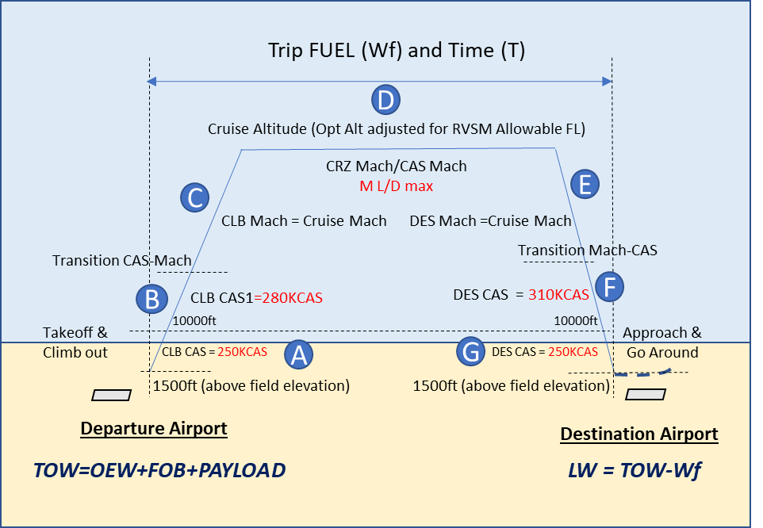

**Fig. 4 Profile of a typical mission.**

The trip fuel and time determination routine were elaborated considering that aircraft departs with a certain takeoff weight (TOW) at the departure airport. The airplane trajectory is the top combination of the climb, cruise and descent flight phases. An interactive algorithm is implemented to determine top of descent point as shown in **Fig. 5**. The algorithm starts computing the top of descent over the destination airport, computing all cruise phase up to there. Then the descent distance is determined from this point and subtracted from the cruise phase, determining a new top of descent. A new computation cycle is then computed from this point and determining a new descent distance. The process is repeated until the difference between the descent points on subsequent runs is less than 0.5 nm. In addition, it is necessary to adjust the TOW, also through an iterative process, considering Payload-Range envelope checks (MZFW, MLW, MAXFUEL and MTOW) as shown in **Fig. 6**. In this cycle the alternate fuel calculation (*Wf alternate*) is computed considering the TOW as estimated landing weight minus a go-around fuel allowance at the destination airport.

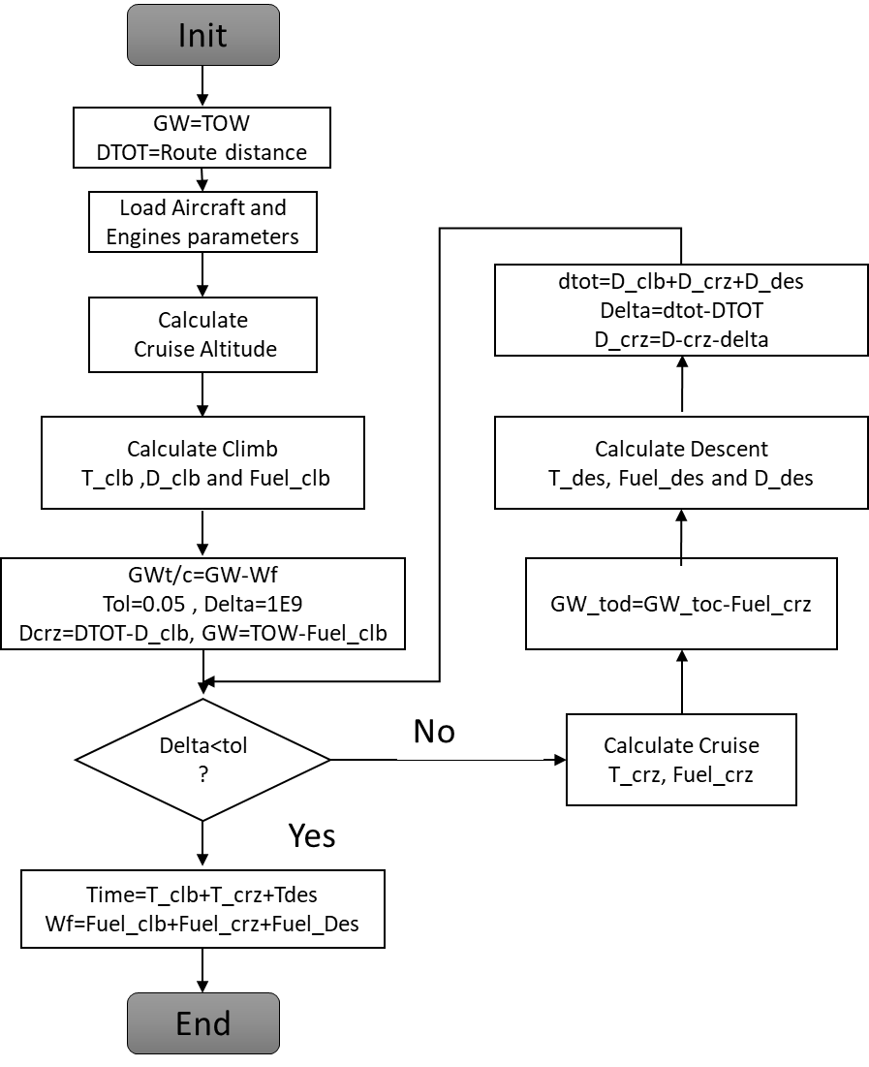

**Fig. 5 Flight profile algorithm, with which the fuel and mission time are calculated.**

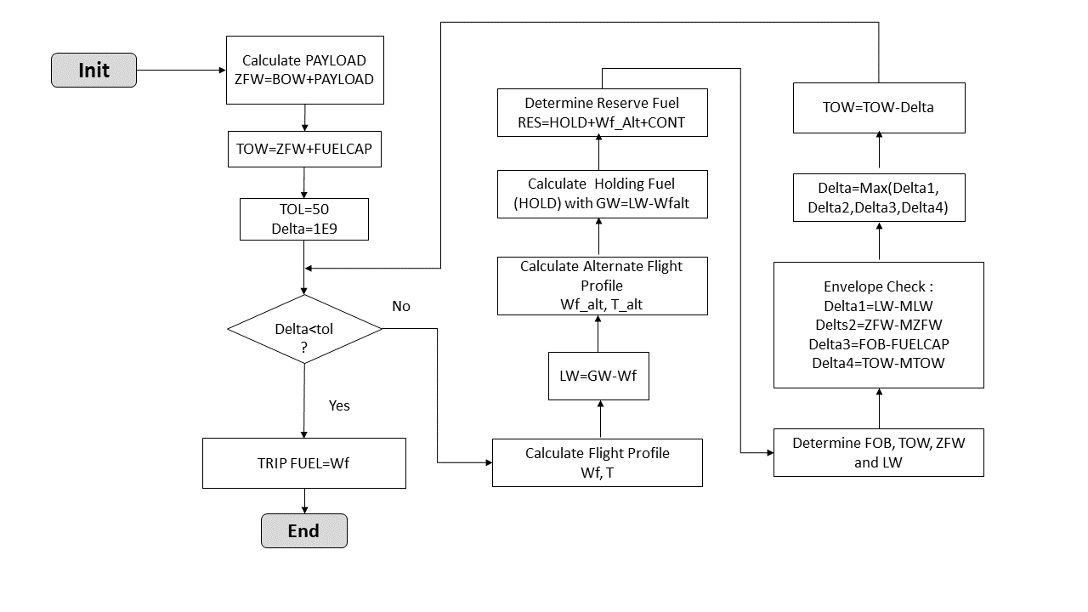

**Fig. 6 Workflow for the airplane mission calculation.**

The Direct Operational Cost computation is also performed in the Mission Performance module and provided as output to the computation of the total network *DOC*. In this process, the single mission *DOC* is determined using empirical formulae expressed as function of Maximum Takeoff Weight (*MTOW*), trip time(*T*), trip fuel (*Wf*) and crew number [42]. Five types of cost components are calculated to compose the *DOC* in each sector and added according to:

|  |  |
| --- | --- |
|  | (24) |

1. **Mission Analysis**

In this module the key results related to all air transport networks and all fleets of airplanes are aggregated. The computations of total network profit (*NP*) and total network DOC (*NDOC*) are done via **Eq. 25** and **Eq. 26,** as function of route frequencies (, departure and arrival delays (), average delay cost per minute (*ID*), sector distance (, aircraft passenger capacity ( and average ticket price ( as follows:

(25)

(26)

In addition, the fleet size required in each aircraft type *k* may be estimated as function of sector block time () and average daily utilization (*DU*) according to:

(27)

(28)

## Engine deck

Engine deck delivers fuel flow and net thrustnecessary for performance calculations in all flight phases of the mission profile. It is based on the thermodynamic model proposed by Benson [51] on turbofan engine operations. The program code is adapted with improvements from an open source code developed by NASA Glenn Research Center [52], enhanced by Mattos et. al [9]. The output parameters from the computation are fuel flow, net thrust mass flow, and exhaust Mach number among other important parameters. The set of input is comprised of overall pressure ratio, fan pressure ratio, fan diameter, turbine inlet temperature, and throttle position. Two calculation steps are built in the module: 1) the design step where all engine characteristics are raised at a given design point (cruise Mach number, cruise altitude and 95% throttle setting) and 2) the analysis step, where it is possible to calculate the engine thrust and fuel flow rate from the geometric characteristics obtained in the design step.

The propulsion module also calculates engine weight, which is used in the component weight estimation process shown in **Fig. 3**. Most of the engine weight estimation methods in airplane conceptual design are based on data from first and second-generation jet engines. Such methods may not be applicable to the current generation of engines, which are much different in design to those of the 70s and 80s. Thus, a new method for turbofan engines weight estimation (applicable the aircraft loaded in the databases) is proposed for this study, according to**:**

|  |  |
| --- | --- |
|  | (29) |

The coefficients and exponents of **Eq. 29** are obtained by an optimization using a genetic algorithm [53]. The objective is the minimization of the square mean error of known engine weights, elaborated from a database comprised of over 20 engines, which embraced a large variety of turbofan engines [54]. **Table III** shows the coefficients and parameters obtained with the optimization process. **Table IV** shows the average parameters used for normalization**. Table V** contains weight estimation errors for some known turbofan engines. It is noticeable that the maximum error obtained is 6.48%, which is considered acceptable for the scope of this study.

**Table III Calculated exponents and coefficients for Eq. 29**

|  |  |
| --- | --- |
| Coefficient/exponent | Value |
| T1 | 2587.2461 |
| T2 | 50.1920 |
| T3 | 154.6179 |
| a | -0.1965 |
| b | -0.07180 |
| c | 1.0435 |
| d | 0.2493 |
| e | -0.3444 |
| f | -0.1455 |

**Table IV Parameters used for normalization in Eq. 29**

|  |  |
| --- | --- |
| Parameter | Value |
|  | 4.69 |
|  | 25.40 |
| [m] | 1.791 |
| [m] | 3.328 |
| [kN] | 148.12 |
| [kg/s] | 464.73 |

**Table V Error estimation for some known engines**

|  |  |
| --- | --- |
| Engine | Deviation [%] |
| CF6-50C | 2.55 |
| JT8D-219 | 0.74 |
| GE CF-34-10A | 6.48 |
| R&R RB211-535C | 0.97 |
| Trent 800-875 | 3.12 |
| Williams FJ-44 | 4.29 |
| Pratt & Whitney PW2040 | 0.44 |
| GE-90/77B | 0.31 |
| R&R Tay 620 | 2.65 |

## Cabin sizing

A MATLAB® code was elaborated to design the cross section of passenger cabin. A considerable sort of cargo containers can be incorporated into cabin configuration. The code requires information such as seat width, aisle width, cabin height, and other considered important parameters to the fuselage sizing (**Fig. 7**). Airplanes with single or two aisles can be handled by the cabin sizing code. For single-aisle cabin, FAR 25 regulation requires on each side of the aisle no more than three rows of seats.

After the cross section is obtained and properly sized, the cabin floor plan is then elaborated. The cabin floor plan code calculates the cabin length, lavatories and galley areas, emergency exit sizing and other important parameters (**Fig. 7**). Two classes are considered in the layout, business and economic. **Fig. 8** shows some cross sections that were designed, illustrating the versatility of the software.

According to regulations, the fuselage design must certify that the emergency exits are above the waterline in event of ditching. A verification is carried out to assure that the waterline is below the doorstep and provides the maximum allowed mass. If MTOW is higher than this maximum allowed weight, the cross section must be resized. The height and width of the cross section are increased until this requirement is met. This implies the changing values for the aisle width and cabin height. Only the fuselage is considered for the calculation, but not the wing and the engine nacelles.

**Fig. 7** **Relevant parameters and considerations for sizing of cockpit and passenger cabin of airliner.**

**Fig. 8** **Examples of cross-section design (not in same scale).**

## Aerodynamics module

The aerodynamic module calculates the drag polar of airliners and estimates the maximum lift coefficient of configuration. The clean wing maximum lift coefficient is calculated by the critical section method [55] with a utilization of the panel code XFOIL [56] for selected wing sections combined with a full potential code [57]. The effect of flaps and slats on the maximum lift coefficient is obtained applying the Datcom method [58].

The calculation of the drag coefficient is performed by splitting the calculation into two parts: the first one is applied to airplane components but wing; the second one is dedicated to lifting surfaces of any planform composed of airfoil of any kind. The methodology for the airframe components but that for the wing was proposed by Torenbeek [41]. The surfaces are all automatically modeled in CAD surfaces (STL format) in MATLAB® and therefore all necessary wetted areas are accurately calculated. **Fig. 9** shows an example of airplane lofting employed for the calculation of those areas. The friction coefficients are dependent on the Mach and Reynolds numbers.

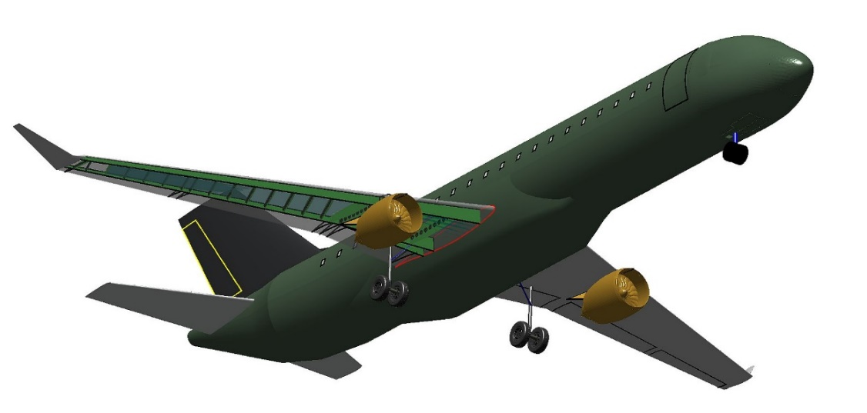

**Fig. 9** **Example of airplane lofting handled by the aerodynamic module.**

The lift and drag coefficient for the wing is estimated by ANN models. Three dedicated ANNs are employed for each drag component, zero-lift, induced, and wave drag. All these ANNs possess two hidden layers with tangent sigmoid transfer functions. The ANNs were trained with tens of thousands results of calculations performed with a wing-body full potential code coupled with an integral boundary layer program. The detailed description of this methodology is described in Ref. [36]. There are additional routines to calculate drag coefficients of landing gear, wind-milling engine, and wing with deflected flaps. **Fig. 10** shows a wing-body configuration of an airliner and some results of a transonic flow over it calculated with the full potential code mentioned in a preceding paragraph. For this configuration, a comparison between the drag coefficient estimated by the ANN model and those from the full potential code is shown in **Fig. 11**.

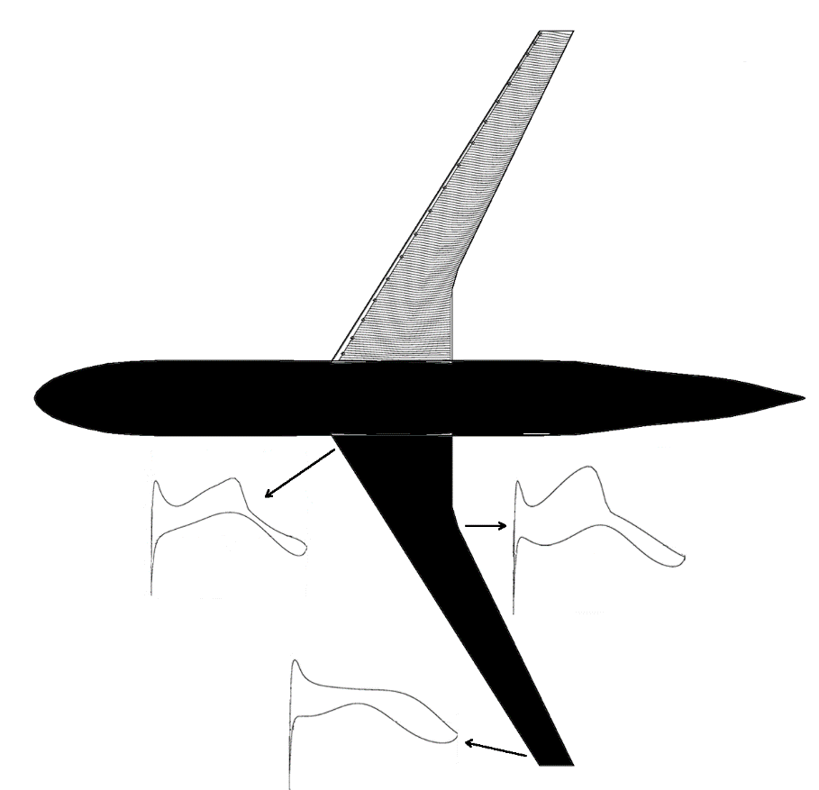.

**Fig. 10** **Streamlines on wing and Cp distributions at three wing stations along span calculated with a full potential code (M∞=0.76, α=1o).**

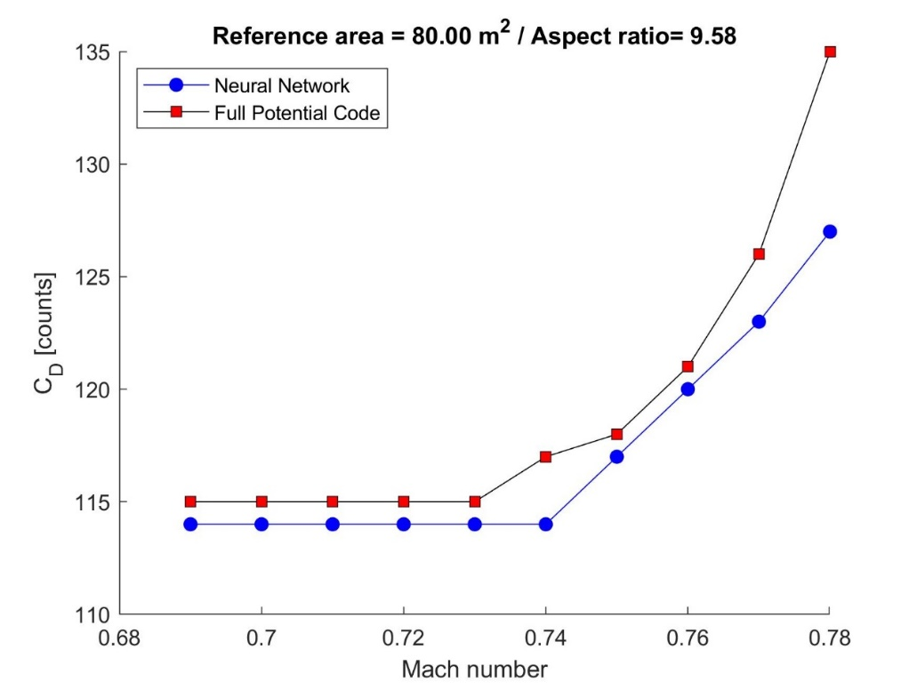

**Fig. 11** **Drag coefficient comparison obtained by numerical analysis and that predicted by ANNs at *CL* of 0.40. The airplane presents a highly swept wing with 80 m2 of planform area.**

## Net Present Value Calculation

Besides the network profit, as described before, the fleet list price is an objective function of the integrated design. In order to calculate the list price of the airplanes considered here, the approach is to proceed with a financial analysis of an aircraft development and serial production program. The complete financial analysis carried out here considers market share, aircraft list price, breakeven point, year of return of investment, and internal rate of return (IRR), all key figures for an investment of a new or re-engined aircraft program. In financial analysis, net present value refers to a series of cash flows over a given period. The present value of a cash flow depends on the interval of time between the beginning of accounting and the period of duration being considered. It also depends on the interest rate. NPV accounts for the time value of money. It provides a method for evaluating and comparing capital projects or financial products with cash flows spread over time, as in loans, investments, payouts from insurance contracts plus many other applications. The following formula is used for NPV calculation:

|  |  |
| --- | --- |
|  | (30) |

The Net Present Value of the aircraft development and commercialization program is calculated from a set of the inputs and hypothesis. This represents the sum of all *NPV(t)* along each year of the lifecycle of the project. By using **Eq. 30** the NPV can be easily obtained:

|  |  |
| --- | --- |
|  | (31) |

The cashflow here is defined as the difference between sales revenue and the development and production costs of the aircraft. In this study, the first 5 years in the lifecycle are considered as development phase, with no sales where non-recurrent costs are dominant, followed by 11 years as the production phase, where sales revenues and recurrent costs are dominant. It is also assumed the minimum acceptable interest rate that may be interpreted as the minimum rate which the capital could be potentially applied in another financial investment, as 5 or 6% per year.

For the computation of the internal rate of return, we use the same formula as NPV. To derive the IRR, an analyst cannot rely on analytical methods. The higher a project's internal rate of return, the more desirable it is to undertake. The following equation is then used for the IRR calculation:

|  |  |
| --- | --- |
|  | (32) |

IRR is uniform for investments of varying types and, as such, IRR can be used to rank multiple prospective projects on a relatively even basis. Assuming the costs of investment are equal among the various projects, the project with the highest IRR would probably be considered the best and be undertaken first. In the present work, the IRR is obtained with an optimization by using the genetic algorithm to find out the market share that delivers a desired IRR.

The project is considered feasible in the event IRR is at least 30%, representing the objective of an NPV optimization task. Thus, the aircraft program financial structure is optimized to provide a desired internal rate of return. For this, the aircraft market share is the variable of optimization. The aircraft list price is dependent on the market share and a discount for a given percent of the aircraft sold is considered, a common practice among manufacturers [59]. The methodology to the recurring and non-recurring cost calculation is strongly based on the one described by Mattos [9].

Camarotti elaborated a semi-automatic tool to issue market outlooks for commercial airplanes [60]. This tool gathers on the internet information and data like oil price forecast and economic growth. Estimative of Revenue Passenger Kilometer are obtained from International Air Transport Association (IATA) annual reports. Air travel demand is developed by building and matching two analysis methodologies: Bottom-up and top-down. The first one involves traffic forecasts within and between individual countries, based on economic estimates, growth momentum, historical series, attractiveness for travel, and liberalization and regulatory projections. Countries are then grouped by geographic regions for route identification within and between such regions. The top-down methodology projects the regional and global markets according to the aeronautical drivers and factors like technological, economical, policy, legislative and other factors [60]. After the synthetization of both methodologies, the specific characteristics of each region of the world are inserted in the model like population dynamics, emergence of new means of transportation and new secondary air services. **Fig. 12** shows some output graphs from Camarotti’s tool for a 20-year-span market outlook starting in 2014.

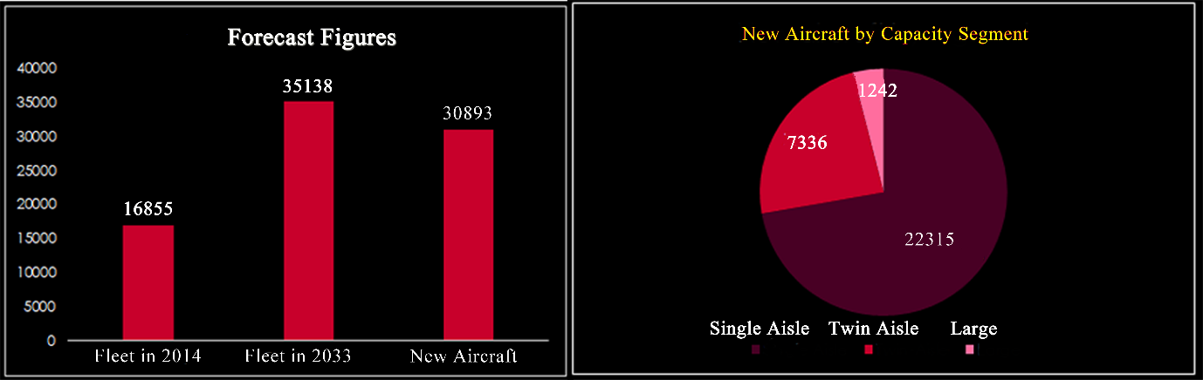

**Fig. 12 Market outlook issued in 2013.**

After the development and production cost structures alongside the size of market for the airplane under analysis are established, the NPV and other parameters for the aircraft program can be calculated. **Fig. 13** shows an example of cashflow and NPV for a 50-seater 16-year-long aircraft program. The design and production cycle parameters for this program are:

1. Timespan of the project of 16 years with 11 years of airplane serial production.
2. Internal rate of return of 30%.
3. Discount of 40% with regard the list price for 40% of airplanes to be sold.
4. List price depends on market share. A “S”-shape function was chosen to model this dependency.
5. Partners of manufacturer accounts for 30% of manufacturing. Partner labor cost is 50% higher than that of manufacturer.
6. Market size for 50-seat jet airliner is 2000 units in a timeframe of 15 years.

**Fig. 14** displays in a bar plot the production over years of the aircraft project under consideration. The NPV optimization task resulted in a market share of 46% of a total market demand of 2000 airplanes.

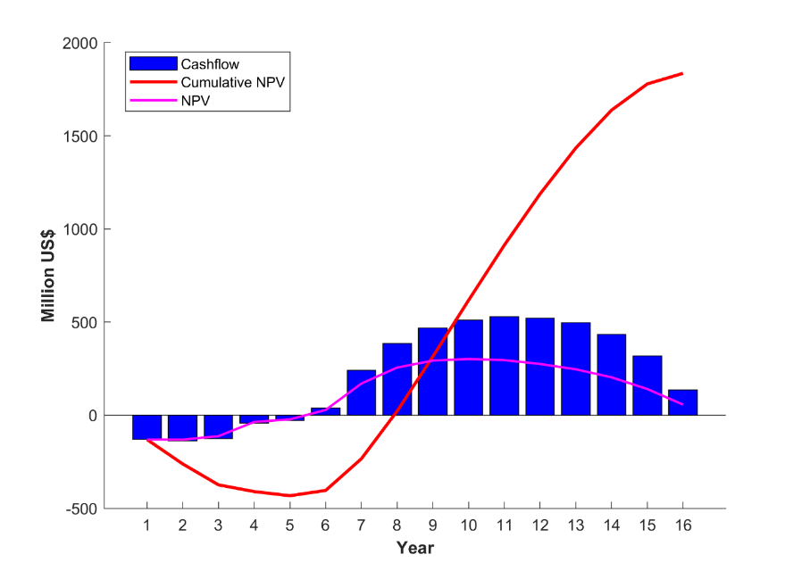

**Fig. 13** **Example of calculation of cashflow and cumulative NPV of a 50-seat airplane program considering a 16-year lifespan for that program.**

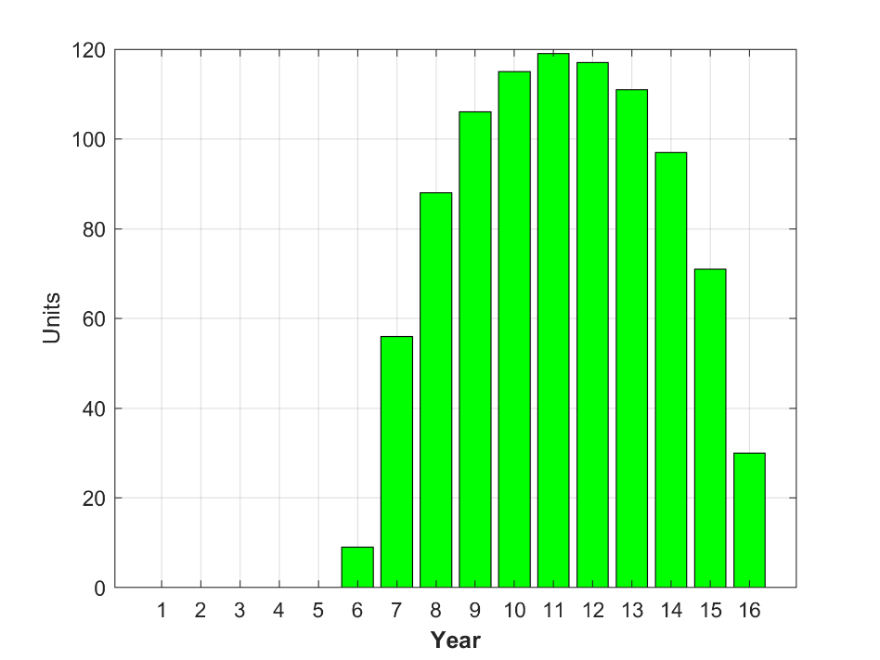

**Fig. 14** **Aircraft production plan.**

# Case study

Since this study intends to find out combinations of airplanes of different passenger capacity that are best suited for a set of cities in Brazil presenting passenger demands, an airplane databank was generated following the methodology that was described in the preceding sections. The airplanes that compose the databank feature different engine characteristics and configurations as well as different wing planform and airfoils. Fuselage seating abreast and passenger accommodation are other parameters that make the airplanes different from each other. Finally, field and cruise performance are additional parameters that drove the design of the airplanes. In total, 42 airplanes were generated and some of them are displayed in **Fig. 15**.

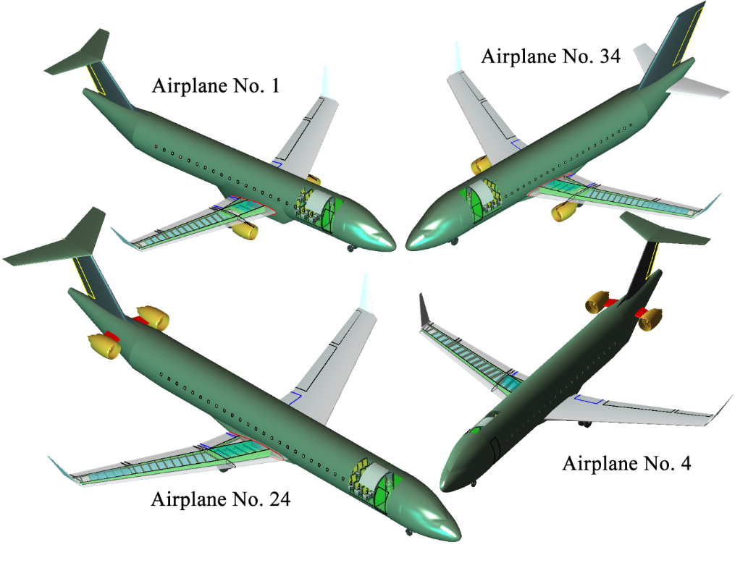

**Fig. 15** **Some airplanes that compose the database (not in same scale).**

**Fig. 16** shows two kinds of DOCs: the cost per nautical mile flown (DOC1) and the cost per nautical mile per passenger. The tendency is clear that the larger the wing area, and therefore the passenger capacity, the larger the DOC1 is. DOC2 presents an inverse behavior to that registered for DOC1. **Table VI** contains some characteristics of all airplanes used in the present study.

**Table VI Airplane considered for airline network simulations**

|  |  |  |  |  |  |  |  |  |
| --- | --- | --- | --- | --- | --- | --- | --- | --- |
| **Airplane ID** | **Passenger single class 32" pitch** | **Seating abreast** | **MTOW [kg]** | **Wing reference area [m2]** | **Wing aspect ratio** | **Range with typical PAX**  **[nm]** | **Engine by-pass ratio** | **Engine location** |
| **1** | 76 | 4 | 34,059 | 74.0 | 8.55 | 1800 | 5.50 | 1 |
| **2** | 76 | 4 | 34,547 | 74.0 | 8.55 | 1800 | 5.50 | 2 |
| **3** | 76 | 4 | 35,335 | 74.0 | 8.55 | 2000 | 5.50 | 2 |
| **4** | 80 | 4 | 36,440 | 76.0 | 8.55 | 2000 | 5.50 | 2 |
| **5** | 80 | 4 | 38,345 | 80.5 | 8.55 | 2100 | 5.50 | 2 |
| **6** | 80 | 4 | 37,749 | 80.5 | 8.55 | 2100 | 6.00 | 2 |
| **7** | 88 | 4 | 40,875 | 93.5 | 8.85 | 2100 | 6.00 | 2 |
| **8** | 52 | 4 | 25,383 | 55.0 | 8.96 | 1700 | 6.12 | 2 |
| **9** | 60 | 4 | 27,325 | 55.0 | 8.75 | 1700 | 6.00 | 2 |
| **10** | 60 | 4 | 26,962 | 55.0 | 8.75 | 1700 | 6.00 | 1 |
| **11** | 64 | 4 | 26,896 | 55.0 | 8.75 | 1700 | 6.00 | 1 |
| **12** | 64 | 4 | 29,072 | 55.0 | 8.75 | 1700 | 6.00 | 2 |
| **13** | 44 | 4 | 22,645 | 48.0 | 8.70 | 1700 | 5.20 | 2 |
| **14** | 44 | 3 | 23,470 | 48.0 | 8.70 | 1700 | 5.20 | 2 |
| **15** | 64 | 4 | 29,880 | 62.0 | 8.20 | 1700 | 5.50 | 2 |
| **16** | 68 | 4 | 30,885 | 62.0 | 8.20 | 1700 | 5.50 | 2 |
| **17** | 68 | 4 | 30,730 | 62.0 | 8.20 | 1700 | 5.50 | 1 |
| **18** | 72 | 4 | 32,400 | 72.0 | 8.20 | 1700 | 5.50 | 1 |
| **19** | 104 | 5 | 43,195 | 93.5 | 8.80 | 1290 | 3.04 | 2 |
| **20** | 125 | 5 | 49,382 | 100.5 | 8.55 | 1590 | 5.54 | 2 |
| **21** | 125 | 5 | 48,982 | 100.5 | 8.65 | 1590 | 6.00 | 2 |
| **22** | 125 | 5 | 47,278 | 95.0 | 8.65 | 1590 | 6.00 | 2 |
| **23** | 125 | 5 | 47,248 | 95.0 | 8.65 | 1590 | 6.00 | 2 |
| **24** | 135 | 5 | 50,064 | 100.0 | 8.75 | 1590 | 6.00 | 2 |
| **25** | 148 | 6 | 55,340 | 100.0 | 8.75 | 1600 | 6.00 | 2 |
| **26** | 148 | 6 | 56,412 | 100.0 | 8.75 | 1800 | 6.00 | 2 |
| **27** | 148 | 6 | 62,451 | 124.0 | 8.75 | 2100 | 5.40 | 2 |
| **28** | 148 | 6 | 63,656 | 124.0 | 8.75 | 2300 | 5.40 | 2 |
| **29** | 152 | 6 | 63,794 | 124.0 | 8.75 | 2400 | 5.40 | 2 |
| **30** | 152 | 5 | 63,500 | 124.0 | 8.85 | 2400 | 5.35 | 1 |
| **31** | 150 | 6 | 63,392 | 120.0 | 9.00 | 2200 | 5.28 | 2 |
| **32** | 150 | 6 | 61,174 | 120.0 | 9.00 | 2000 | 5.28 | 2 |
| **33** | 150 | 6 | 61,592 | 120.0 | 9.00 | 2000 | 5.28 | 1 |
| **34** | 144 | 6 | 61,958 | 120.0 | 9.00 | 2200 | 5.28 | 1 |
| **35** | 114 | 6 | 52,624 | 120.0 | 9.00 | 2200 | 5.28 | 2 |
| **36** | 90 | 5 | 43,341 | 95.0 | 9.00 | 2200 | 5.40 | 2 |
| **37** | 95 | 5 | 44,154 | 95.0 | 9.00 | 2200 | 5.40 | 2 |
| **38** | 95 | 5 | 43,362 | 90.0 | 7.90 | 2200 | 5.40 | 2 |
| **39** | 60 | 4 | 27,246 | 62.0 | 8.00 | 1600 | 5.28 | 2 |
| **40** | 60 | 4 | 27,458 | 64.0 | 7.90 | 1600 | 5.28 | 2 |
| **41** | 60 | 4 | 27,035 | 58.0 | 7.90 | 1600 | 5.28 | 2 |
| **42** | 92 | 4 | 42,597 | 93.5 | 8.30 | 2400 | 5.38 | 2 |
| Remarks:   * For performance calculations: 100-kg passenger weight; alternate airport distant 200 nm; 45-min holding; cruise Mach number at MMO-0.02. * Besides planform parameters, airplane wings may differ among them by airfoil composition. * Engine location =1 means underwing configuration; = 2 placed at rear fuselage | | | | | | | | |

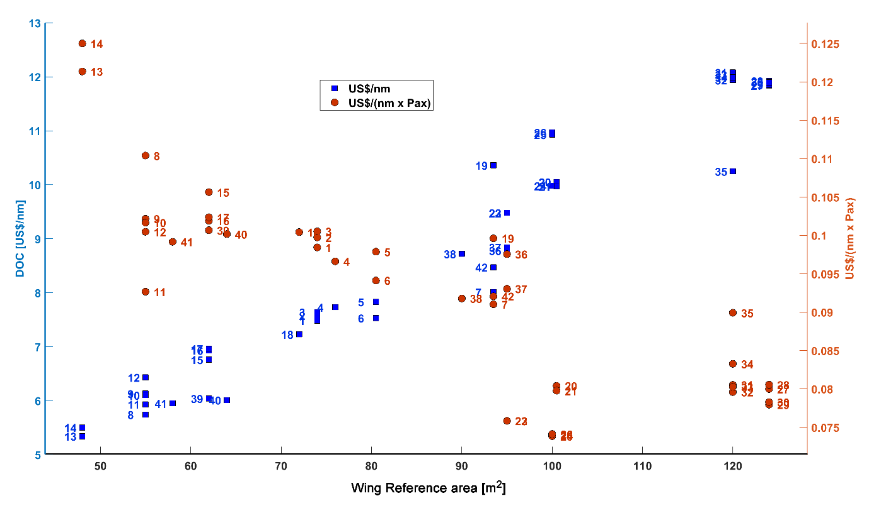

**Fig. 16** **US$/nm and US$/(nm x Pax) as function of wing reference area for the airplanes that compose the databank used in the present simulations. All calculations performed for the range with typical passenger payload departing at MTOW.**

The case study we considered consists on the determination of the optimum air transport network within a wide operational area in Brazil covered by its twenty major airports. Distances *dij* (used in the network optimization module) and true headings *Θij* (used in the mission analysis module) between city pairs are determined via haversine formula for loxodromic routes [61], according to:

(33)

(34)

*dij* = *R* ⋅ *c* (35)

(36)

where *R* is earth’s average radius (6.367 km = 3.438 nm).

A bias of 3% is applied on all great circle distances to accommodate airway-route differences. **Table A.I** in Appendix A shows the calculated route distances between the Brazilian airports. The airport data used in the mission analysis computations was extracted from the Brazilian Aeronautical Information Publication (AIP) [62]. **Tables A.II** and **A.III (Appendix A)** show the airport data and associated city econometric parameters used in the gravitational model. It is assumed that the airline operating this network has 20% of passenger market share and does not actuate in the cargo segment. **Table A.III (Appendix A)** shows the estimated daily passenger demand, considering this share. The proposed demand model (given by **Equation 4)** was calibrated using the city pair demands data related to the 21 chosen Brazilian routes in 2014, 2015 and 2016, extracted from the Brazilian Civil Aviation Authority (ANAC) statistical reports [63]. A log-linear regression model was applied to calibrate the exponents for the proposed equation. Values obtained were: *K0*=3.5770, *K1*=0.4157*, K2*=-0.0388, *K3*=-0.1643 and *K4*=0.1331. The Pearson coefficient associated with this regression was 0.63, considered reasonable for air transportation analysis.

Average delays at each airport are considered by the model proposed by Newell [64] as function of runway configuration and capacity: for departure delays, which occur on ground, 10 minutes for airports with two or more active runways (for SBGR, SBGL and SBBR) and 5 minutes for airports with 1 active runway (for SBCT, SBPA and SBSV). Arrival delays, associated with terminal holdings and cruise speed reductions, are assumed to be 5 minutes at airports with two or more active runways and 3 minutes for airports with one active runway. Airline operational parameters assumed in this study are listed in **Table VII**. Also, the revenue to ticket price ratio (*k1*) and cost to DOC ratio (*k2*) are assumed as 1.1 and 1.3 respectively.

**Table VII Airline Operations Parameters**

|  |  |
| --- | --- |
| Parameters | Value |
| Average Daily Aircraft Utilization [h] | 12 |
| Average Turn Around Time [min] | 45 |
| Takeoff and Initial Climb out Fuel allowance [kg] | 200 |
| Takeoff and Initial Climb out Time allowance [min] | 3 |
| Approach and Landing Fuel allowance [kg] | 100 |
| Approach and Landing Time allowance [min] | 2 |
| Go Around Fuel allowance [kg] | 200 |
| Go Around Time allowance [min] | 3 |
| Average Taxi Out Time (from gate to runway threshold) | 10 |
| Average Taxi In Time (from runway exit to gate) | 5 |
| Total Passenger Weight (including baggage) | 100 |
| Average Ticket Price [US$] | 110 or 200 |
| Average Inflight Delay Cost [US$/min] | 20 |
| Fuel Cost [US$/kg] | 1.431 or 2.80 |
| Total Operational Costs/Direct Operational Costs ratio | 1.3 |
| Total Revenue/Ticket Revenue ratio | 1.1 |

# Analysis of results

Brazil represents a significant aviation market in the world with 112.5 million of passengers transported in 2017, 90.6 million in domestic flights, according to ANAC [65]. The revenue of the major airlines reached US$ 11.8 billion considering an average exchange rate of 3.20 Dollar/Real [65]. The optimizations tasks carried out here considered 21 Brazilian cities with their passenger demands calculated by a gravitational model.

Some optimization runs were performed. The baseline one considers an average ticket price of US$ 110 and the fuel price per kg of US$ 1.431. For the second optimization run, the average ticket price was increased to US$ 200. Finally, the third simulation set up the average ticket price back to US$ 110 but increased the fuel price per kg to US$ 2.80. All runs were finished after approximately 55 generations with the genetic algorithm MOGA-II from MATLAB® [66].

**Fig. 17** shows the Pareto front resulted from the baseline optimization run considering the objective functions network daily profit and fleet acquisition amount. For clarity, just some unfeasible individuals are marked by empty circles. The airplane No. 25. A 148-seat 6-abreast airliner is present in all triplet of the Pareto front. In the low-capacity segment, both 44-seat and a 60-seat airplane were selected. In the middle-capacity sector, there is a larger seat variation, ranging from 72 to 95. **Fig. 18** are flight connections performed by airplanes of P1 individual belonging to the Pareto front. **Fig. 19** shows the connections for the network with maximum profit, i. e., those operated by the airplanes Nos. 10, 18, and 25. Manaus, capital of Amazon, in the North of Brazil, is not served by any flight. **Table VIII** contains a summary of the Pareto individuals and the network density.

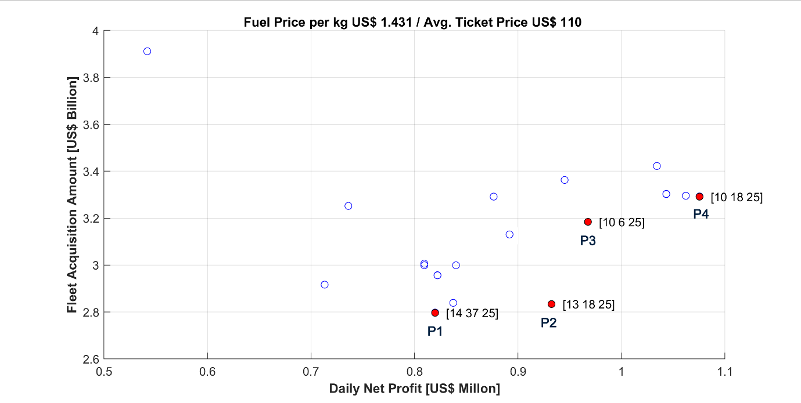

**Fig. 17** **Pareto front of the baseline optimization task. Some dominated individuals are shown in empty blue circle markers only for clarity (Fuel price/kg = US$ 1.431; Average ticket price = US$ 110).**

**Table VIII** **Individuals selected in the Pareto front resulted from the optimization task**

|  |  |  |  |  |  |  |  |  |
| --- | --- | --- | --- | --- | --- | --- | --- | --- |
| **Design ID** | | **Airplane**  **ID** | **Seat**  **Capacity** | **Design**  **Range [nm]** | **MTOW**  **[kg]** | **Network**  **Density** | **List price**  **[in million US$]** | **Network Profit**  **[in million US$]** |
| **P1** | AC1 | 14 | 44 | 1,700 | 23,470 | 0.29 | 30.9 | 0.82 |
| AC2 | 37 | 95 | 2,200 | 44,154 | 69.5 |
| AC3 | 25 | 148 | 1,600 | 55,340 | 67.6 |
| **P2** | AC1 | 13 | 44 | 1,700 | 22,645 | 0.32 | 30.5 | 0.93 |
| AC2 | 18 | 72 | 1,700 | 32,400 | 49.8 |
| AC3 | 25 | 148 | 1,600 | 55,340 | 67.6 |
| **P3** | AC1 | 10 | 60 | 1,700 | 26,962 | 0.30 | 38.0 | 0.97 |
| AC2 | 6 | 80 | 2,100 | 37,749 | 57.2 |
| AC3 | 25 | 148 | 1,600 | 55,340 | 67.6 |
| **P4** | AC1 | 10 | 60 | 1,700 | 26,962 | 0.31 | 38.0 | 1.08 |
| AC2 | 18 | 72 | 1,700 | 32,400 | 49.8 |
| AC3 | 25 | 148 | 1,600 | 55,340 | 67.6 |

|  |
| --- |
|  |
|  |
|  |

**Fig. 18** **Network P1. Connections performed by Airplanes 14, 37, and 25.**

|  |
| --- |
|  |
|  |
|  |

**Fig. 19** **Network P4. Connections performed by Airplanes 10, 18, and 25.**

**Tables IX** to **XII** provide details of the four networks belonging to the Pareto front of the baseline optimization run. Amount of money for fleet acquisition ranges from 2.8 to 3.3 billion USD and on average 60 thousand passengers are transported daily. The figure of the network with maximum profit rewritten to a yearly basis reveals a total passenger transportation of 108.5 million and a total revenue of US$ 13.7 billion, which is in good agreement with the data from ANAC [65].

**Table IX Results for the network with minimum fleet purchase amount (P1)**

|  |  |
| --- | --- |
| **Parameter** | **Value** |
| Total Distance flown [nm] | 394,262 |
| Avg. network clustering index | 0.60 |
| Number of passengers | 59,556 |
| Estimated CO2 emission [ton] | 1928 |
| Total fuel [ton] | 628 |
| TOTAL COST [US$] | 6,386,342 |
| TOTAL REVENUE [US$] | 7,206,276 |
| TOTAL PROFIT [ US$] | 819,933 |
| Network DOC [US$/nm] | 12.5 |
| Network Profit [US$/PAX. nm].10-5 | 3.491 |
| Estimated number of aircraft | 50 |
| Total fleet investment [Billions of US$] | 2.797 |
| Fleet investment-yearly profit ratio | 9.345 |

**Table X** **Results for the P2 network**

|  |  |
| --- | --- |
| **Parameter** | **Value** |
| Total Distance flown [nm] | 433,761 |
| Avg. network clustering index | 0.67 |
| Number of passengers | 62,191 |
| Estimated CO2 emission [ton] | 2013 |
| Total fuel [ton] | 638 |
| TOTAL COST [US$] | 6,592,721 |
| TOTAL REVENUE [US$] | 7,525,111 |
| TOTAL PROFIT [ US$] | 932,390 |
| Network DOC [US$/nm] | 11,7 |
| Network Profit [US$/PAX. nm].10-5 | 3.46 |
| Estimated number of aircraft | 57 |
| Total fleet investment [Billions of US$] | 2.833 |
| Fleet investment-yearly profit ratio | 8.324 |

**Table XI Results for the P3 network**

|  |  |
| --- | --- |
| **Parameter** | **Value** |
| Total Distance flown [nm] | 414,085 |
| Avg. network clustering index | 0.59 |
| Number of passengers | 60,385 |
| Estimated CO2 emission [ton] | 1938 |
| Total fuel [ton] | 615 |
| TOTAL COST [US$] | 6,339,009 |
| TOTAL REVENUE [US$] | 7,306,585 |
| TOTAL PROFIT [ US$] | 967,576 |
| Network DOC [US$/nm] | 11.8 |
| Network Profit [US$/PAX. nm].10-5 | 3.87 |
| Estimated number of aircraft | 59 |
| Total fleet investment [Billions of US$] | 3.184 |
| Fleet investment-yearly profit ratio | 9.016 |

**Table XII Results for the network with maximum profit (P4)**

|  |  |
| --- | --- |
| **Parameter** | **Value** |
| Total Distance flown [nm] | 422,694 |
| Avg. network clustering index | 0.63 |
| Number of passengers | 61,871 |
| Estimated CO2 emission [ton] | 1978 |
| Total fuel [ton] | 628 |
| TOTAL COST [US$] | 6,410,966 |
| TOTAL REVENUE [US$] | 7,486,391 |
| TOTAL PROFIT [ US$] | 1,075,424 |
| Network DOC [US$/nm] | 11.7 |
| Network Profit [US$/PAX. nm].10-5 | 4.112 |
| Estimated number of aircraft | 64 |
| Total fleet investment [Billions of US$] | 3.293 |
| Fleet investment-yearly profit ratio | 8.389 |

For another optimization task, the ticket price was raised to US$ 200 from the US$ 110 of the baseline simulation. The resulting Pareto front is shown in **Fig. 20**. Network profit experienced a huge increase as can be observed in **Fig**. **20**. In this scenario the 60-seat airplane No. 10 left the scene, dominated by 44-seat airplanes, the twinjets No. 13 and 14. In the capacity range above 99 seats, airplane No. 25 was joined by the 135-seat airplane No. 24 and the slightly heavier airplane No. 26. The triplet P7 seems to be a natural choice to this Pareto that emerged because profit is outstanding with a slight increase of the fleet purchase cost when compared to the P2 to P6 individuals.

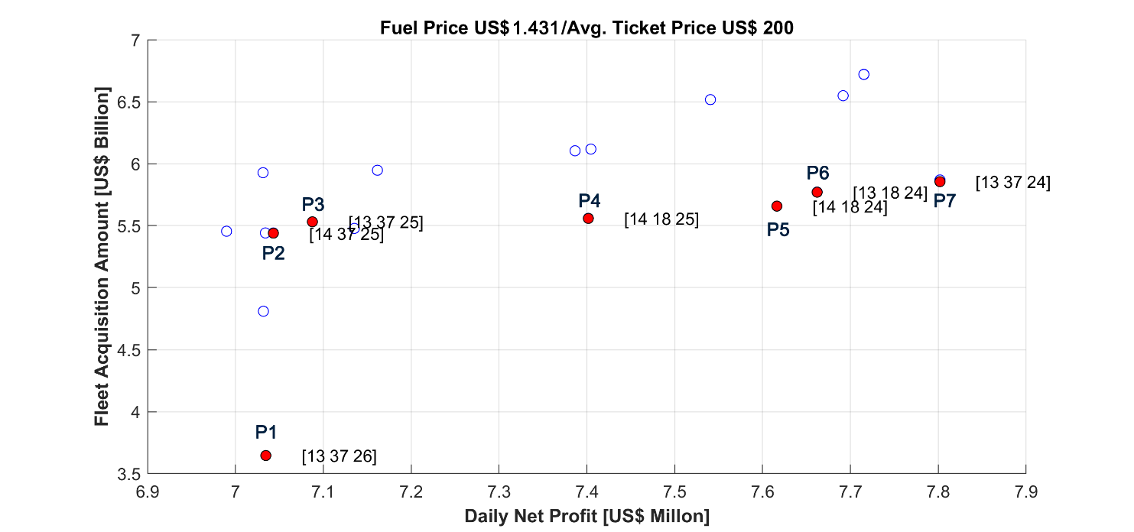

**Fig. 20** **Pareto front of the optimization task with increased average ticket price. Some dominated individuals are shown in empty blue circle markers only for clarity (Fuel price/kg = US$ 1.431; Average ticket price = US$ 200).**

**Fig. 21** shows the airplane connections operated by the triplet {13, 37, 24} airplanes for network environment with increased ticket price. The increase in number of connections among cities regarding the previous simulation is noticeable. Manaus is now served by air service, by airplanes Nos. 37 and 24. **Table XIII** shows relevant data related to the P7 network, which records a daily profit of US$ 7.8 million.

|  |
| --- |
|  |
|  |
|  |
| **Fig. 21 P7 individual of Pareto that resulted from the simulation considering increased ticket price. Connections displayed are performed by Airplanes No. 13, 37, and 24.** |

**Table XIII Data for the network with maximum profit (P7)**

|  |  |
| --- | --- |
| **Parameter** | **Value** |
| Total Distance flown [nm] | 1,426,771 |
| Avg. network clustering index | 0.66 |
| Number of passengers | 126,577 |
| Estimated CO2 [ton] | 1928 |
| Total fuel [ton] | 1873 |
| TOTAL COST [US$] | 20,045,005 |
| TOTAL REVENUE [US$] | 27,846,940 |
| TOTAL PROFIT [ US$] | 7,801,934 |
| Network DOC [US$/nm] | 10.8 |
| Network Profit [US$/PAX. nm].10-5 | 4.32 |
| Estimated number of aircraft | 112 |
| Airline’s Total Fleet Investment [Billions of US$] | 5.853 |
| Fleet investment-yearly profit ratio | 2.06 |

The third optimization task, with increased fuel price, resulted in the Pareto front shown in **Fig. 22**. The combination {14,18,25} is the single individual from Pareto presenting profit that is non-negative or close to zero. It is a triplet that is present in the Pareto fronts from previous optimization runs. **Fig. 23** indicates a large drop in connections that resulted from this scenario. **Table XIV** contains some relevant data for the network operated by the triplet {14,18,25}. The daily profit is now approximately US$ 50,000 and the number of airplanes is one third of that from the baseline scenario.

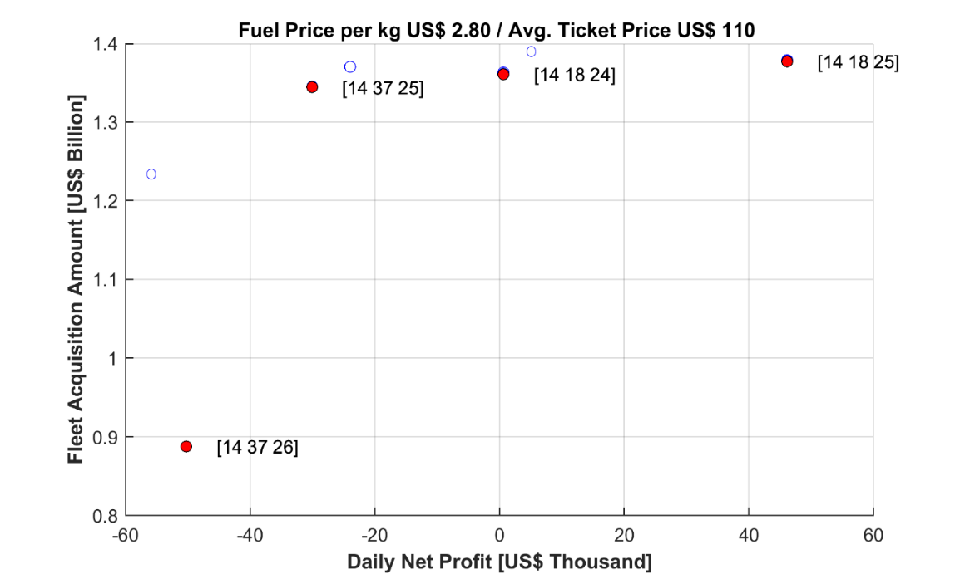

**Fig. 22 Pareto front of the simulation with increased fuel price.**

|  |  |  |
| --- | --- | --- |
|  |  |  |
| **Fig. 23** **Connections displayed are performed by Airplanes No. 14, 38, and 25 from the simulation that considered increased fuel price.** | | |

**Table XIV Results for the network with maximum profit**

|  |  |
| --- | --- |
| **Parameter** | **Value** |
| Total Distance flown [nm] | 227,601 |
| Number of passengers | 43,375 |
| Estimated CO2 [ton] | 1140 |
| Total fuel [ton] | 362 |
| TOTAL COST [US$] | 5,202,220 |
| TOTAL REVENUE [US$] | 5,248,375 |
| TOTAL PROFIT [ US$] | 46,155 |
| Network DOC [US$/nm] | 17.6 |
| Network Profit [US$/PAX. nm].10-5 | 4.68 |
| Estimated number of aircraft | 28 |
| Airline’s Total Fleet Investment [Billions of US$] | 1.380 |
| Avg. network clustering index | 0.56 |

# Concluding remarks

A methodology to design optimal airplanes to operate in airline networks of any choice was elaborated. The integrated transportation system design approach of the present work enables detailed analysis of the two different main components, namely the airplane and city connections, that comprise the transportation system and define how they work together. Utilizing the formulations developed to define the network, airplanes and cities to be served by air transport, a concurrent optimization of the transportation system can be obtained. The methodology was applied to a Brazilian network consisting of 21 major airports in that country. The demand for those cities was generated by using a gravitational model. In addition, a database consisting of 42 realistic and detailed airplanes with different seating capacity was generated. Accurate calculation of true mission profiles was performed, thanks to an ANN model for aerodynamic coefficient estimation, a robust generic turbofan engine deck and other proper modeling of aeronautical disciplines.

Three optimization runs were carried out considering variations of average ticket and fuel prices. The highlighted airplanes, which are present in the three optimization runs and recorded better profit, are the No. 14, 18, 24, and 25, a 44-seater, a 72-passenger twinjet, a 135-seater 5-abreast jetliner and a 148-seater 6-abreast airliner, respectively. Considering the baseline scenario, the 60-seat No. 10 is a good choice. The 148-seat No. 25 is undoubtedly a forerunner, able to guarantee minimal profit, in combination with the Nos. 14 and 18 in times of rising fuel prices. It is comparable in terms of passenger capacity with Airbus A220-300 and the veteran McDonnell Douglas MD-87.

The impact of the introduction of turboprop into the airplane database is something important to analyze in the future. They may eventually replace the 44-seat twinjets that emerged in some optimal solutions. Among the three largest airlines that operate domestic flights in Brazil, Azul is the only one that operates a combined fleet of jet and turboprop airliners.

The inclusion of the vehicle and network into the transportation system operations a more efficient network architecture can be obtained that reduces operating costs or maximizes profit. This methodology can be applied to strategic planning or investments at a major cargo or passenger airline or provide insight about market needs to aircraft designers. The present methodology can also be used to evaluate, for example, the impact of consideration of scope clause issues or airplane emissions on network topology.

**Bibliography**

[1] R. Doganis, Flying Off Course IV: Airline Economics and Marketing, Routledge, 2009.

doi: http://doi.org/10.4324/9781315402987

[2] J. C. Medau, Allocation of aircraft to flights considering aircraft operational, maintenance and performance restrictions. Doctorate dissertation, São Paulo: University of São Paulo, 2017.

[3] D. Klabian, Large-scale models in the airline industry, Kluwer Academic Publishers, 2014.

doi: http://doi.org/10.1007/0-387-25486-2_6

[4] A. Rabetanety, J. Calmet and C. Schoen, Airline Schedule Planning Integrated Flight Schedule Design and Product Line Design, Karlsuhe: Universty of Karlsuhe, 2006.

doi: https://doi.org/10.1287/trsc.1030.0026

[5] C. Hane, C. Barnhart, C. Johnson, E. Marsten, R. Nemhauser and G. Sigismondi, "The fleet assignment problem: solving a large-scale integer program," Georgia Institute of Technology, 1995.

doi: http://doi.org/10.1007/BF01585938

[6] D. J. Caetano and N. D. Gualda, "An exact model for airline flight network optimization based on transport momentum and load factor," Transportes, pp. 14-26, 2017.

doi: http://doi.org/10.14295/transportes.v25i4.1383

[7] D. J. Caetano and N. D. F. Gualda, "A Flight Schedule and Fleet Assignment Model," in 12th World Conference on Ait Transport Research, Lisbon (Portugal), 2010.

[8] H. Gurkan, S. Gureal and S. Altuk, "An integrated approach for airline scheduling, aircraft fleeting and routing with cruise speed control," Transportation Research, vol. Part C, pp. 38-57, 2016.

doi: http://doi.org/10.2174/97816810832781180301

[9] B. S. Mattos, J. A. Fregnani and P. C. Magalhães, Conceptual Design of Green Transport Airplane., Book Series: Frontiers in Aerospace Science ed., vol. 3, Bentham Books, 2018.

doi: http://doi.org/10.2174/97816810832781180301

[10] R. K. Akhuja, T. L. Magnanti, J. B. Orlin and M. R. Reddy, "Applications in Network Optimization," in Handbooks of Operations Research and Management Science, Kanpur (India), 1995, pp. 1-83.

doi: http://doi.org/10.1016/S0927-0507(05)80118-5

[11] J. F. Campbell, "Integer Programming formulations of discrete hub location programming," European Journal of Operational Research, pp. 387-405, 1994.

doi: http://doi.org/10.1016/0377-2217(94)90318-2

[12] T. Aykin, "The hub location and routing problem," European Journal of Operational Research, vol. 83, pp. 200-219, 1993.

doi: http://doi.org/10.1016/0377-2217(93)E0173-U

[13] P. Jaillet, G. Song and G. Yu, "Airline Network Design and Hub Allocation Problems," Location Science, vol. 4, pp. 195-212, 1996.

doi: http://doi.org/10.1016/S0966-8349(96)00016-2

[14] P. J. Lederer and R. S. Nambimandom, "Airline Network Design," Operations Research, pp. 7865-804, 1998.

doi: http://dx/doi.org/10.1287/opre.46.6.785

[15] A. D. Evans, A. Schafer and L. Dray, "Modelling Airline Network Routing and Scheduling under Airport Capacity Constraints," in 26th Congress of International Council of the Aeronautical Science, Anchorage, 2008.

doi: http:// doi.org/10.2514/6.2008-8855

[16] D. Bing, "Reliability Analysis for Aviation Airline Network Based on Complex Network," Journal of Aerospace Technologies Management, vol. 6, no. 2, pp. 193-201, 2014.

doi: http://doi.org/10.5028/jatm.v6i2.295

[17] T. Grosche, F. Rothlauf and A. Heinzl, "Gravity models for airlines passenger volume estimation," Journal of Air Transport Management, pp. 175-183, 2007.

doi: http://doi.org/10.1016/j.jairtraman.2007.02.001

[18] O. Wojan, "Airline Network Structure and the Gravity Model," University of Hamburg and Lufthansa Technik AG, Hamburg, 2000.

doi: http://doi.org/10.1016/S1366-5545(00)00026-0

[19] W. A. Crossley and M. Mane, "System of Systems Inspired Aircraft Sizing Applied to Commercial Aircraft / Airline Problems," in AIAA 5th Aviation, Technology, Integration, and Operations Conference (ATIO), Arlington, 2005.

doi: http://dx/doi.org/10.2514/6.2005-7426

[20] Nusawardhana and W. A. Crossley, "Concurrent Aircraft Design and Variable Resource Allocation in Large Scale Fleet Networks," in 9th AIAA Aviation Technology, Integration, and Operations Conference (ATIO) , 2009.

doi: http://doi.org/10.2514/6.2009-6977

[21] C. Taylor and O. Week, "Integrated Transportation Network Design Optimization," in 47th AIAA Conference, 2006.

doi: http://dx/doi.org/10.2514/6.2006-1912

[22] G. Bower and I. Kroo, "Multiobjective Aircraft Optimization for minimum cost and emissions over specific route networks," in 8th AIAA ATIO , 2008.

doi: http://doi.org/10.2514/6.2008-8905

[23] N. Davedralingam and W. Crossley, "Concurrent aircraft design and network design incorporating passenger demand models," in 9th AIAA Aviation Technology, 2009.

doi: http://doi.org/10.2514/6.2009-6971

[24] N. Davendralingam and W. Crossley, "Robust Approach for concurrent aircraft design and airline network design," Journal of Aircraft, vol. 51, no. 6, pp. 1773-1783, 2014.

doi: http://doi.org/10.2514/6.2011-6927

[25] N. Davendralingam and W. Crossley, "Robust Optimization of Aircraft Design and Airline Network Design Incorporating Econometric Trends," in 11th AIAA Aviation Technology, 2010.

doi: http://doi.org/10.2514/6.2011-6927

[26] L. Siqueira, V. Loureiro and B. Silva de Mattos, "The Suited Airliner for an Existing Airline Network," in 11th AIAA, 2009.

doi: http://dx.doi.org/10.2514/6.2009-2206

[27] L. Versiani, P. Paglione and B. Silva de Matos, "Multi-Objective Design Optimization Framework for Conceptual Design of Families of Aircrafts," in 44th AIAA Aerospace Sciences Meeting, 2006.

doi: http://doi.org/10.2514/6.2006-1328

[28] J. T. Hwang and J. R. Martins, "Allocation-mission-design optimization of next-generation aircraft using a parallel computational framework," in 57th AIAA/ASCE/AHS/ASC Structures, Structural Dynamics, and Materials Conference, AIAA SciTech Forum, San Diego, 2016.

doi: http://doi.org/10.2514/6.2016-1662

[29] R. J. Balling and J. Sobieszczanski-Sobieski, "Optimization of coupled systems - A critical overview of approaches," AIAA Journal, vol. 34, 1996.

doi: http://doi.org/10.2514/6.1994-4330

[30] N. V. Queipo, R. Haftka, S. Shyy, T. Goel, R. Vaidyanathan and P. K. Tucker, "Surrogated Based Analysis and Optimization," Progress in Aerospace Sciences, pp. 1-28, 2005.

doi: http://org/10.1016/j.paerosci.2005.02.001

[31] A. T. Isikveren, "Quasi-Analytical Modelling and Optimization Techniques for Transport Aircraft Design," Royal Stockholm of Technology (KTH), Stockholm, 2002.

[32] J. Cavalcanti, B. S. Mattos and P. Paglione, "Optimal Conceptual Design of Transport Aircraft," in 11th AIAA/ISSMO Multidisciplinary Analysis and Optimization Conference , Portsmouth, 2006.

doi: http://doi.org/10.2514/6.2006-7022

[33] L. V. Cabral, P. Paglione and B. S. Mattos, "Multi-Objective Design Optimization Framework for Conceptual Design of Families of Aircraft," in 44th AIAA Aerospace Sciences Meeting and Exhibit, Reno, 2006.

doi: http://doi.org/10.2514/6.2006-1328

[34] R. Henderson, "Multidisciplinary Design Optimization of Airframe and Engine for Emissions Reduction," Master Thesis, University of Toronto, Toronto, 2009.

[35] L. Siqueira, B. S. Mattos and V. Loureiro, "The Suited Airliner for an Existing Airline Network," in 50th AIAA/ASME/ASCE/AHS/ASC Structures, Structural Dynamics, and Materials Conference, California, 2009.

doi: http://doi.org/10.2514/6.2009-2206

[36] N. R. Secco and B. S. Mattos, "Artificial Neural Networks Applied to Airplane Design," in 53rd AIAA Aerospace Sciences Meeting, AIAA SciTech Forum, 2015.

doi: http://dx.doi.org/10.2514/6.2015-1013

[37] MathWorks Inc., "Mixed-Integer Linear Programming Algorithms," MathWorks Inc., September 2019, URL: http://www.mathworks.com/help/optim/ug/mixed-integer-linear-programming-algorithms.html#bt6n8vs. [ cited 15 September 2019].

[38] Y. Zang, "Solving Large-Scale Linear Programs by Interior-Point Methods under MATLAB environment," Baltimore, 1995.

doi: http://doi.org/10.1080/10556789808805699

[39] C. M. Fonseca and P. J. Fleming, "Genetic Algorithms for Multiobjective Optimization: Formulation, Discussion and Generalization," in Proceedings of the Fifth International Conference, San Mateo (CA), 1993.

[40] M. D. McKay, R. J. Beckman and W. J. Conover, "A comparison of three methods for selecting values of input variables in the analysis of output from computer code," Technometrics, pp. 55-61, 1970.

doi: http://doi.org/10.2307/1268522

[41] E. Torenbeek, Advanced Aircraft Design, Wiley & Sons, 2013.

doi: 10.1002/9781118568101

[42] A. K. Kundu, Aircraft Design, Cambridge University Press, 2010.

doi: http://doi.org/10.1017/CBO9780511844652

[43] P. Langenegger, “Otimização Aero Estrutural na Fase de Projeto de Aeronave,” Instituto Tecnológico de Aeronáutica, Undergraduate Thesis, São José dos Campos, 2012.

[44] The Boeing Company, "Jet Transport Performance Methods," Boeing Commercial Aircraft, Seattle, USA, 1998.

[45] ICAO, International Civil Aviation Organization, "Manual of the ICAO Standard Atmosphere - Doc.7488/3, Third Edition," Montreal, 1993.

[46] ICAO, International Civil Aviation Organization, "Annex 11 to the Convention on International Civil Aviation - Air Traffic Services," Montreal, 2001.

[47] ICAO, International Civil Aviation Organization, "Manual of Implementation of a 300m (1000ft) vertical Separation Minimum between FL290 and FL410 - Doc 9574," Montreal, 2002.

[48] T. Vicenty, "Direct and Inverse solutions of geodesic on the ellipsoid with application of nested equations," Survey Review, vol. 23, no. 176, pp. 88-93, 1975.

doi: http:// doi.org/10.1179/sre.1975.23.176.88

[49] Agência Nacional de Aviação Civil (ANAC), "Regulamento Brasileiro de Aviação Civil No.121 - Requisitos Operacionais: Operações Domésticas, Suplementares e de Bandeira," Brasília, 2010.

[50] J. Fregnani, C. Muller and A. R. Correia, "A fuel tankering model applied to a domestic airline network," Journal fo Advanced Transportation, pp. 386-398, 2011.

doi: : http:// doi.org/10.1002/atr.162

[51] T. Benson, "An interactive educational tool for turbojet engines," in AIAA 31st Joint Propulsion Conference Exhibit, 1995.

doi: http:// doi.org/10.2514/6.1995-3055

[52] NASA Glenn Research Center, "EngineSim Version1.8a," NASA, 2016. [Online]. Available: http://www.grc.nasa.gov/WWW/K-12/airplane/enginesim.html. [Accessed 30 January 2018].

[53] MathWorks, "Genetic Algorithm," MathWorks, December 2017. [Online]. Available: http://www.mathworks.com/discovery/genetic-algorithm.html. [Accessed December 2017].

[54] Jane's, "Jane's Aero Engines," IHS Markit, December 2017, URL: http://janes.ihs.com.[cited 22 April 2017]

[55] B. Singh, "A Medium-Fidelity Method for Rapid Maximum Lift Estimation," Delft University, Delft, 2017.

[56] M. Drela, "XFOIL - Subsonic Airfoil Development System," October 2018. URL: http://web.mit.edu/drela/Public/web/xfoil/. [cited 1 October 2018].

[57] B. S. Mattos, "Numerischer Entwurf von transsonischen Flügeln und Tragflügelprofilen unter Anwendung des AF2-Algorithmus zur Lösung de vollständigen Potentialgleichung," Universität Stuttgart, Stuttgart, 1995.

[58] S. Gudmundsson, "Maximum Lift Coefficient," Elsevier, 2018. [Online]. Available: http://www.sciencedirect.com/topics/engineering/maximum-lift-coefficient. [Accessed September 1029].

[59] J. Morrison, J. Hasman and S. Sgouridis, "Game Theory Analysis of The Impact of Single Aisle Aircraft Competition Fleet Emissions," Massachusetts Institute of Technology, Cambridge, 2011.

doi: http:// doi.org/10.2514/6.2011-6844

[60] Camarotti, V. B, “Estudo de Drivers de Mercado, Metodologia e Desenvolvimento de Ferramenta Semi-Automática para Elaboração de Projeções de Mercado de Aviação de Linha**,”** undergraduate thesis, Instituto Tecnológico de Aeronáutica, 2014.

[61] C. C. Robusto, "The cosine-harvesine formula," The American Mathematical Monthly, vol. 64, no. 1, pp. 30-40, 1957.

doi: http://doi.org/10.2307/2309088

[62] Brazilian Airspace Control Department, "Aeronautical Information Publication (AIP) - AGA Part," Institute of Aeronautical Cartography, Rio de Janeiro, 2016.

[63] Agência Nacional de Aviação Civil (ANAC), "Anuário do Transporte Aéreo, Agência Nacional de Aviação Civil (ANAC), 2014, 2015 and 2016. [Online]. URL://www.anac.gov.br/assuntos/dados-e-estatisticas/mercado-de-transporte-aereo/anuario-do-transporte-aereo/dados-do-anuario-do-transporte-aereo. [cited 30 January 2018].

[64] G. F. Newell, "Airport Capacity and Delays," Transportation Science, pp. 201-241, 1979.

doi: http://doi.org/10.1287/trsc.13.3.201

[65] Agência Brasileira de Aviação Civil, “Anuário de Transporte Aéreo 2017,” ANAC, Brasília, 2018.

[66] Mathworks, Inc., "gamultiobj," Mathworks, Inc, 2018.URL: http://www.mathworks.com/help/gads/gamultiobj.html. [cited 12 August 2019].

**APPENDIX A – NETWORK DATA**

**Table A.I:** Airport data

|  |  |  |  |  |  |  |  |
| --- | --- | --- | --- | --- | --- | --- | --- |
| Airport  Code  (IATA) | Airport  Location/Name | Reference  Latitude  [deg] | Reference  Longitude  [deg] | Reference  Elevation  [ft] | Magnetic  Variation  [deg] | Average  Departure Delay  [min] | Average  Arrival Delay  [min] |
| **AJU** | Aracaju/Santa Maria | -10.9840 | -37.0703 | 23 | -23 | 2 | 2 |
| **BEL** | Belém/Val de Caes Intl | -1.3793 | -48.4763 | 54 | -19 | 3 | 3 |
| **BSB** | Brasília/Jucelino Kubitscheck Intl | -15.8635 | -47.9276 | 3497 | -20 | 10 | 5 |
| **CGH** | Sao Paulo/Congonhas | -23.6267 | -46.6554 | 2631 | -20 | 3 | 3 |
| **CGR** | Mato Grosso do Sul/Campo Grande Intl | -20.4694 | -54.6703 | 559 | -20 | 3 | 3 |
| **CNF** | Belo Horizonte/Confins Intl | -19.6338 | -43.9689 | 2715 | -21 | 3 | 3 |
| **CWB** | Curitiba/Afonso Pena Intl | -25.5285 | -49.1758 | 2988 | -18 | 5 | 5 |
| **FLN** | Florianópolis/Hercílio Luz Intl | -27.6705 | -48.5472 | 20 | -17 | 2 | 2 |
| **FOR** | Fortaleza/Pinto Martins | -3.7763 | -38.5326 | 82 | -21 | 2 | 2 |
| **GIG** | Rio de Janeiro/Tom Jobim (Galeão) Intl | -22.8089 | -43.2436 | 28 | -21 | 10 | 5 |
| **GRU** | São Paulo/André Franco Montoro (Guarulhos) Intl | -23.4321 | -46.4695 | 2459 | -20 | 10 | 5 |
| **GYN** | Goiânia/Santa Genoveva | -16.6320 | -49.2207 | 2450 | -19 | 2 | 2 |
| **MAO** | Eduardo Gomes/Manaus Intl | -3.0386 | -60.0497 | 264 | -14 | 2 | 2 |
| **MCZ** | Maceió/Zumbi dos Palmares | -9.5108 | -35.7917 | 387 | -22 | 2 | 2 |
| **NAT** | Natal/São Gonçalo do Amarante Intl | -5.9114 | -35.2477 | 169 | -22 | 2 | 2 |
| **POA** | Porto Alegre/Salgado Filho Intl | -29.9944 | -51.1714 | 11 | -15 | 3 | 3 |
| **REC** | Recife/Guararapes Intl | -8.1268 | -34.9230 | 33 | -23 | 2 | 2 |
| **SDU** | Rio de Janeiro/Santos Dumont | -22.9105 | -43.1631 | 11 | -21 | 3 | 3 |
| **SLI** | São Luiz/Marechal Cunha Machado Intl | -2.5854 | -44.2341 | 178 | -20 | 2 | 2 |
| **SSA** | Salvador/Antônio Carlos Magalhães Intl | -12.9110 | -38.3310 | 64 | -23 | 2 | 2 |
| **VIX** | Vitória/Goiabeiras | -20.2581 | -40.2864 | 11 | -23 | 2 | 2 |

**Table A.II:** Econometric data

|  |  |  |  |  |
| --- | --- | --- | --- | --- |
| Airport  Location/Name | Population  (2016) | Catchment  Radius  [km] | Buying  Power Index  (2016) | GDP 2016  [x10E6 BRL] |
| **Aracaju/Santa Maria** | 641523 | 100 | 36.00 | 14893787 |
| **Belém/Val de Caes Intl** | 1446042 | 200 | 20.00 | 28706165 |
| **Brasília/Jucelino Kubitscheck Intl** | 2977216 | 100 | 37.65 | 197432059 |
| **Sao Paulo/Congonhas** | 12038175 | 20 | 36.68 | 628064882 |
| **Campo Grande Intl** | 805000 | 100 | 21.07 | 16970000 |
| **Belo Horizonte/Confins Intl** | 2523794 | 200 | 30.85 | 87656760 |
| **Curitiba/Afonso Pena Intl** | 1893997 | 100 | 43.74 | 78892229 |
| **Florianópolis/Hercílio Luz Intl** | 477798 | 100 | 34.58 | 17328527 |
| **Fortaleza/Pinto Martins** | 2609716 | 100 | 36.00 | 56728828 |
| **Rio de Janeiro/Tom Jobim (Galeão) Intl** | 6498837 | 100 | 33.68 | 299849795 |
| **São Paulo/André Franco Montoro (Guarulhos) Intl** | 12038175 | 100 | 36.68 | 628064882 |
| **Goiânia/Santa Genoveva** | 1021709 | 100 | 37.00 | 46094735 |
| **Eduardo Gomes/Manaus Intl** | 2094391 | 200 | 20.00 | 67572523 |
| **Maceió/Zumbi dos Palmares** | 1021709 | 100 | 36.00 | 18302279 |
| **Natal/São Gonçalo do Amarante Intl** | 877662 | 100 | 36.00 | 19076030 |
| **Porto Alegre/Salgado Filho Intl** | 1481019 | 100 | 41.31 | 63990644 |
| **Recife/Guararapes Intl** | 1625583 | 100 | 36.38 | 50688395 |
| **Rio de Janeiro/Santos Dumont** | 6498837 | 20 | 33.68 | 299849795 |
| **São Luiz/Marechal Cunha Machado Intl** | 1091868 | 100 | 25 | 26326087 |
| **Salvador/Antônio Carlos Magalhães Intl** | 2938092 | 100 | 24.94 | 56624041 |
| **Vitória/Goiabeiras** | 1100000 | 100 | 30 | 23370919 |

**Table A.III:** Estimated Passengers Demand per day (20% Market share)

|  |  |  |  |  |  |  |  |  |  |  |  |  |  |  |  |  |  |  |  |  |
| --- | --- | --- | --- | --- | --- | --- | --- | --- | --- | --- | --- | --- | --- | --- | --- | --- | --- | --- | --- | --- |
| **Dep**  **Apt** | **Arrival Airport** | | | | | | | | | | | | | | | | | | | |
| **AJU** | **BEL** | **BSB** | **CGH** | **CNF** | **CWB** | **FLN** | **FOR** | **GIG** | **GRU** | **GYN** | **MAO** | **MCZ** | **NAT** | **POA** | **REC** | **SDU** | **SLI** | **SSA** | **VIX** |
| **AJU** | 0 | 324 | 420 | 723 | 385 | 464 | 302 | 450 | 524 | 637 | 345 | 351 | 307 | 328 | 434 | 343 | 594 | 321 | 347 | 220 |
| **BEL** | 324 | 0 | 411 | 718 | 383 | 465 | 295 | 444 | 525 | 633 | 333 | 278 | 381 | 352 | 429 | 394 | 596 | 256 | 401 | 223 |
| **BSB** | 420 | 411 | 0 | 834 | 443 | 537 | 357 | 627 | 623 | 734 | 325 | 427 | 503 | 479 | 514 | 525 | 707 | 420 | 533 | 273 |
| **CGH** | 723 | 718 | 834 | 0 | 720 | 760 | 517 | 1084 | 910 | 0 | 668 | 736 | 861 | 822 | 781 | 898 | 1033 | 734 | 917 | 438 |
| **CNF** | 385 | 383 | 443 | 720 | 0 | 485 | 318 | 586 | 507 | 631 | 362 | 398 | 462 | 444 | 468 | 484 | 577 | 393 | 477 | 222 |
| **CWB** | 464 | 465 | 537 | 760 | 485 | 0 | 297 | 691 | 622 | 678 | 429 | 473 | 551 | 524 | 458 | 574 | 705 | 473 | 600 | 290 |
| **FLN** | 302 | 295 | 357 | 517 | 318 | 297 | 0 | 450 | 407 | 460 | 286 | 300 | 359 | 341 | 284 | 374 | 460 | 303 | 384 | 188 |
| **FOR** | 450 | 444 | 627 | 1084 | 586 | 691 | 450 | 0 | 795 | 955 | 512 | 496 | 517 | 452 | 642 | 525 | 901 | 425 | 599 | 339 |
| **GIG** | 524 | 525 | 623 | 910 | 507 | 622 | 407 | 795 | 0 | 796 | 504 | 543 | 626 | 600 | 604 | 654 | 0 | 537 | 658 | 299 |
| **GRU** | 637 | 633 | 734 | 0 | 631 | 678 | 460 | 955 | 796 | 0 | 588 | 649 | 759 | 724 | 692 | 791 | 904 | 647 | 808 | 385 |
| **GYN** | 345 | 333 | 325 | 668 | 362 | 429 | 286 | 512 | 504 | 588 | 0 | 343 | 411 | 392 | 412 | 429 | 572 | 342 | 438 | 223 |
| **MAO** | 351 | 278 | 427 | 736 | 398 | 473 | 300 | 496 | 543 | 649 | 343 | 0 | 413 | 385 | 434 | 428 | 616 | 307 | 431 | 233 |
| **MCZ** | 307 | 381 | 503 | 861 | 462 | 551 | 359 | 517 | 626 | 759 | 411 | 413 | 0 | 365 | 514 | 363 | 710 | 376 | 441 | 263 |
| **NAT** | 328 | 352 | 479 | 822 | 444 | 524 | 341 | 452 | 600 | 724 | 392 | 385 | 365 | 0 | 487 | 353 | 680 | 345 | 445 | 255 |
| **POA** | 434 | 429 | 514 | 781 | 468 | 458 | 284 | 642 | 604 | 692 | 412 | 434 | 514 | 487 | 0 | 534 | 684 | 439 | 560 | 275 |
| **REC** | 343 | 394 | 525 | 898 | 484 | 574 | 374 | 525 | 654 | 791 | 429 | 428 | 363 | 353 | 534 | 0 | 742 | 388 | 475 | 277 |
| **SDU** | 594 | 596 | 707 | 1033 | 577 | 705 | 460 | 901 | 0 | 904 | 572 | 616 | 710 | 680 | 684 | 742 | 0 | 609 | 746 | 339 |

1. PhD Student, Aircraft Design Department
2. Associate Professor, Aircraft Design Department
3. Full Professor, Department of Structures